 | United Nations | A/HRC/35/L.18/Rev.1
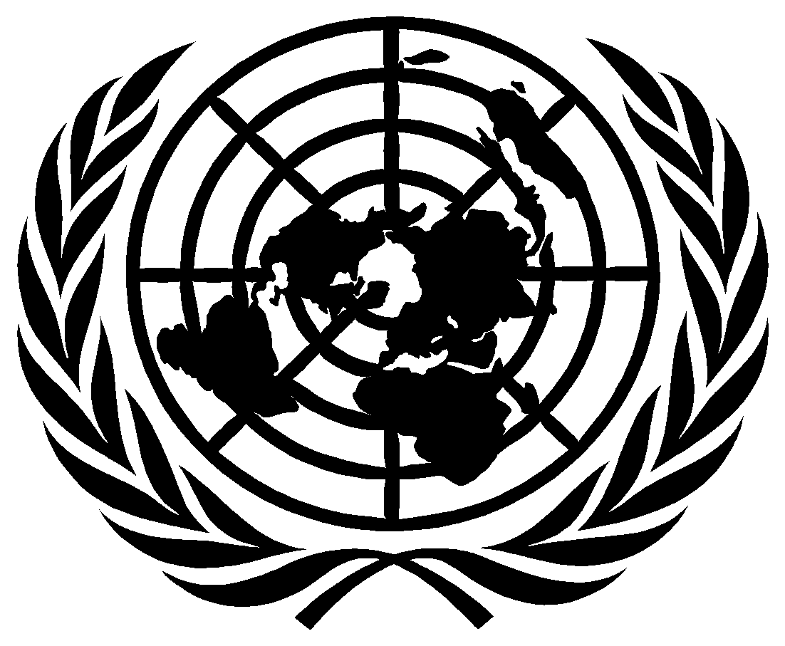 | General Assembly |  | Distr.: Limited  21 June 2017  Original: English
Human Rights Council
Thirty-fifth session
6–23 June 2017
Agenda item 3
Promotion and protection of all human rights, civil,
political, economic, social and cultural rights,
including the right to development
Argentina,* Belgium, Brazil, Bulgaria,* Colombia,* Ecuador, Egypt, Haiti,* Honduras,* Luxembourg,* Malta,* Mozambique,* Paraguay, Peru,* Portugal, Romania,* Spain,* Timor-Leste,* Qatar, Thailand,* Turkey:* draft resolution
35/… The right of everyone to the enjoyment of the highest attainable standard of physical and mental health in the implementation of the 2030 Agenda for Sustainable Development
The Human Rights Council,
Guided by the purposes and principles of the Charter of the United Nations,
Reaffirming the Universal Declaration of Human Rights, and recalling the International Covenant on Economic, Social and Cultural Rights, the International Convention on the Elimination of All Forms of Racial Discrimination, the Convention on the Elimination of All Forms of Discrimination against Women, the Convention on the Rights of the Child and the Convention on the Rights of Persons with Disabilities,
Reaffirming also that all human rights are universal, indivisible, interrelated, interdependent and mutually reinforcing,
Reaffirming further that all human beings are born free and equal in dignity and rights, and recognizing that these rights derive from the inherent dignity of the human person,
Reaffirming that the right of everyone to the enjoyment of the highest attainable standard of physical and mental health is a human right as enshrined in, inter alia, the Universal Declaration of Human Rights, the International Covenant on Economic, Social and Cultural Rights and the Convention on the Rights of the Child, as well as, with respect to non-discrimination, in the International Convention on the Elimination of All Forms of Racial Discrimination, the Convention on the Elimination of All Forms of Discrimination against Women and the Convention on the Rights of Persons with Disabilities, and that such a right derives from the inherent dignity of the human person,
Recalling Human Rights Council resolution 33/9 of 29 September 2016 and all relevant previous resolutions and decisions on the right of everyone to the enjoyment of the highest attainable standard of physical and mental health adopted by the Council, the General Assembly and the Commission on Human Rights,
Recalling also the Declaration on the Right to Development, which, inter alia, establishes that States should take, at the national level, all measures necessary for the realization of the right to development and should ensure, inter alia, equality of opportunity for all in their access to basic resources, such as health-care services,
Reaffirming World Health Assembly resolutions 69.1 of 27 May 2016 on strengthening essential public health functions in support of the achievement of universal health coverage, 69.11 of 28 May 2016 on health in the 2030 Agenda for Sustainable Development and 70.15 of 31 May 2017 on promoting the health of refugees and migrants,
Reaffirming also General Assembly resolution 70/1 of 25 September 2015, entitled “Transforming our world: the 2030 Agenda for Sustainable Development”, in which the Assembly adopted the outcome document of the United Nations summit for the adoption of the post-2015 development agenda, recognizing that eradicating poverty in all its forms and dimensions, including extreme poverty, is the greatest global challenge and an indispensable requirement for sustainable development, and envisaging a world free of poverty, hunger, disease and want, a world of universal respect for human rights and human dignity that includes equitable and universal access to health-care services and social protection, and where physical, mental and social well-being are assured,
Recognizing that the 2030 Agenda is guided by the purposes and principles of the Charter of the United Nations, including full respect for international law, and is grounded in the Universal Declaration of Human Rights, international human rights treaties, the United Nations Millennium Declaration and the 2005 World Summit Outcome, and is informed by other instruments such as the Declaration on the Right to Development,
Reaffirming that the Goals and targets of the 2030 Agenda are integrated and indivisible, balance the three dimensions of sustainable development, namely, the economic, social and environmental, seek to achieve gender equality and the empowerment of women and girls, and are global in nature and universally applicable, taking into account different national realities, capacities and levels of development and respecting national policy space and priorities,
Welcoming the Sustainable Development Goals, including, inter alia, Goal 3, Ensure healthy lives and promote well-being for all at all ages, and its specific and interlinked targets as well as other health-related Goals and targets,
Welcoming also the inclusion of gender equality and empowerment of all women and girls as a stand-alone goal, and its integration into all Goals and targets of the 2030 Agenda and throughout the implementation process,
Recognizing, in particular, the commitments made by States in the 2030 Agenda to leave no one behind, and to endeavour to reach the furthest behind first, founded on the dignity of the human person, and reflecting the principles of equality and non-discrimination,
Reaffirming the right of refugees and migrants to the enjoyment of the highest attainable standard of physical and mental health,
Concerned about the interrelatedness between poverty and the realization of the right of everyone to the enjoyment of the highest attainable standard of physical and mental health, in particular the fact that ill health can be both a cause and a consequence of poverty,
Recognizing the need for States to address the social, economic and environmental determinants of health, as well as to address holistically a range of barriers arising from inequality and discrimination that impede access to health-care services,
Noting with concern that, for millions of people throughout the world, especially for women and girls, the full enjoyment of the right to the highest attainable standard of physical and mental health remains a distant goal,
Recognizing that women, youth, children, indigenous persons, older persons, persons with disabilities, persons living with HIV and people of African descent face particular challenges and multifaceted and intersecting forms of discrimination in the enjoyment of the right to the highest attainable standard of physical and mental health,
Deeply concerned that persons with mental health conditions or psychosocial disabilities, in particular persons using mental health services, may be subject to, inter alia, widespread discrimination, stigma, prejudice, violence, social exclusion and segregation, unlawful or arbitrary institutionalization, overmedicalization and treatment practices that fail to respect their autonomy, will and preferences,
Deeply concerned also that, despite the impressive reductions in maternal mortality rates achieved since 1990, according to the World Health Organization, in 2015, there were an estimated 303,000 maternal deaths of women and girls, which were largely preventable, and that many more women and girls suffer serious and sometimes lifelong injuries, which have severe consequences for their enjoyment of their human rights and their overall well-being,
Deeply concerned further that more than 5,900,000 children under 5 years of age die each year, mostly from preventable and treatable causes, owing to inadequate access or lack of access to integrated and quality maternal, newborn and child health-care services, to early childbearing, and to health determinants, such as safe drinking water and sanitation, safe and adequate food and nutrition, and that mortality remains highest among children belonging to the poorest and most marginalized communities,
Regretting the high number of people still without access to affordable, safe, efficacious and quality medicines, vaccines, diagnostics and medical devices, and underscoring that improving such access could save millions of lives every year, and noting with deep concern that, according to the World Health Organization in its World Medicines Situations Report of 2011, at least one third of the world’s population has no regular access to medicines, while recognizing that the lack of access to medicines is a global challenge that affects people not only in developing countries but also in developed countries, even though the disease burden is disproportionately high in developing countries,
Noting with concern that approximately 54 per cent of persons living with HIV are in need of treatment, many of whom do not know their HIV status,
Concerned at the instances of multiple or aggravated forms of discrimination, stigma, violence and abuses that affect the enjoyment of the right of everyone to the enjoyment of the highest attainable standard of physical and mental health, and recalling the importance that States adopt or strengthen law, policies and practices to eradicate any form of discrimination, stigma, violence and abuse in health-care services,
Recognizing that universal health coverage implies that all people have access without discrimination to nationally determined sets of the needed promotive, preventive, curative, palliative and rehabilitative essential health-care services, including sexual and reproductive health-care services, and essential, safe, affordable, efficacious and quality medicines, vaccines, diagnostics and medical devices, while ensuring that the use of these services does not expose the users to financial hardship, with a special emphasis on the poor, vulnerable and marginalized segments of the population,
Underscoring that the full realization of human rights and fundamental freedoms for all, including the right of everyone to the enjoyment of the highest attainable standard of physical and mental health, contributes to the efforts to implement the health-related Sustainable Development Goals, while recognizing that, inter alia, discrimination, stigma, corruption, violence and abuse are major obstacles in this regard,
Underscoring also that the implementation of the health-related Sustainable Development Goals contributes to the full realization of human rights and fundamental freedoms for all, including the right of everyone to the enjoyment of the highest attainable standard of physical and mental health,
Stressing the importance of strengthening the meaningful participation of women in decision-making processes and developing gender-sensitive multisectoral health policies and programmes in order to address their needs,
Recognizing the need for States, in cooperation with international organizations and civil society, including non-governmental organizations and the private sector, to create favorable conditions at the national, regional and international levels to ensure the full and effective enjoyment of the right of everyone to the highest attainable standard of physical and mental health,
Recognizing also the positive contribution of the work of the Human Rights Council, including through its universal periodic review mechanism, to national, regional and global efforts for the implementation of the Sustainable Development Goals and targets,
1. Takes note of the report of the Special Rapporteur on the right of everyone to the enjoyment of the highest attainable standard of physical and mental health on the 2030 Agenda for Sustainable Development;
2. Calls upon States to respect, protect and fulfil the right of everyone to the enjoyment of the highest attainable standard of physical and mental health, with special attention to groups in vulnerable situations;
3. Urges States to work towards the full implementation of all Sustainable Development Goals and targets with a view to contributing to the realization of the right of everyone to the enjoyment of the highest attainable standard of physical and mental health, including, inter alia, the following targets of the 2030 Agenda for Sustainable Development:
Target 3.1: By 2030, reduce the global maternal mortality ratio to less than 70 per 100,000 live births;
Target 3.2: By 2030, end preventable deaths of newborns and children under 5 years of age, with all countries aiming to reduce neonatal mortality to at least as low as 12 per 1,000 live births and under-5 mortality to at least as low as 25 per 1,000 live births;
Target 3.3: By 2030, end the epidemics of AIDS, tuberculosis, malaria and neglected tropical diseases and combat hepatitis, water-borne diseases and other communicable diseases;
Target 3.4: By 2030, reduce by one third premature mortality from non-communicable diseases through prevention and treatment and promote mental health and well-being;
Target 3.5: Strengthen the prevention and treatment of substance abuse, including narcotic drug abuse and harmful use of alcohol;
Target 3.6: By 2020, halve the number of global deaths and injuries from road traffic accidents;
Target 3.7: By 2030, ensure universal access to sexual and reproductive health-care services, including for family planning, information and education, and the integration of reproductive health into national strategies and programmes;
Target 3.8: Achieve universal health coverage, including financial risk protection, access to quality essential health-care services and access to safe, effective, quality and affordable essential medicines and vaccines for all;
Target 3.9: By 2030, substantially reduce the number of deaths and illnesses from hazardous chemicals and air, water and soil pollution and contamination;
Target 3.a: Strengthen the implementation of the World Health Organization Framework Convention on Tobacco Control in all countries, as appropriate;
Target 3.b: Support the research and development of vaccines and medicines for the communicable and non-communicable diseases that primarily affect developing countries, provide access to affordable essential medicines and vaccines, in accordance with the Doha Declaration on the TRIPS Agreement and Public Health, which affirms the right of developing countries to use to the full the provisions in the Agreement on Trade-Related Aspects of Intellectual Property Rights regarding flexibilities to protect public health, and, in particular, provide access to medicines for all;
Target 3.c: Substantially increase health financing and the recruitment, development, training and retention of the health workforce in developing countries, especially in least developed countries and small island developing States;
Target 3.d: Strengthen the capacity of all countries, in particular developing countries, for early warning, risk reduction and management of national and global health risks; and
Target 5.6: Ensure universal access to sexual and reproductive health and reproductive rights as agreed in accordance with the Programme of Action of the International Conference on Population and Development and the Beijing Platform for Action and the outcome documents of their review conferences;
4. Also urges States to bring their laws, policies and practices, including their strategies towards the implementation of the health-related Sustainable Development Goals, fully into compliance with their obligations under international human rights law, and to review and, where necessary, repeal those that are discriminatory;
5. Encourages States to promote effective, full and meaningful participation of all, in particular those in vulnerable situations, in the design, implementation and monitoring of law, policies and programmes relevant to realizing the right of everyone to the enjoyment of the highest attainable standard of physical and mental health and to implementing the health-related Sustainable Development Goals, including strategies for universal health coverage;
6. Also encourages States, when monitoring progress in the implementation of the health-related Sustainable Development Goals, to use high-quality, timely and reliable data, disaggregated by income, gender, age, race, ethnicity, migratory status, disability, geographic location and other characteristics relevant in national contexts, while respecting human rights principles, including participation, self-identification, transparency, privacy and accountability;
7. Further encourages States to empower users of health-care services to know and demand their rights, including through health and human rights literacy, and to provide human rights education and training for health workers, with special focus on non-discrimination, free and informed consent, confidentiality, privacy and the duty to provide treatment, and to exchange best practices in this regard;
8. Encourages States, when reporting on the implementation of the Sustainable Development Goals to the high-level political forum on sustainable development, to include in their national voluntary reports references to the human rights dimension, in particular to the right of everyone to the enjoyment of the highest attainable standard of physical and mental health;
9. Calls upon the international community to continue to assist developing countries in promoting the full realization of the right of everyone to the enjoyment of the highest attainable standard of physical and mental health, including through access to medicines, in particular essential medicines, vaccines, diagnostics and medical devices that are affordable, safe, efficacious and of quality; financial and technical support and training of personnel, while recognizing that the primary responsibility for promoting and protecting all human rights rests with States; and recognizes the fundamental relevant importance of the transfer of environmentally sound technologies on favourable terms, including on concessional and preferential terms, as mutually agreed;
10. Calls upon States to fulfil their respective official development assistance commitments, including the commitments by many developed countries to achieve the target of 0.7 per cent of gross national income for official development assistance, and urges those developed countries that have not done so to make concrete efforts in this regard in accordance with their commitments;
11. Encourages the Special Rapporteur, while considering the many ways towards the full realization of the right of everyone to the enjoyment of the highest attainable standard of physical and mental health, to continue to focus on the human rights dimension that could contribute to the effective implementation of the health-related Sustainable Development Goals and targets;
12. Also encourages the Special Rapporteur to continue to advise States, intergovernmental organizations, civil society, the private sector and other stakeholders on effective and sustainable practices to respect, protect and fulfil the right of everyone to the enjoyment of the highest attainable standard of physical and mental health in the implementation of the 2030 Agenda and to follow up and participate in relevant international forums and major events in this regard, including the annual sessions of the World Health Assembly and of the high-level political forum;
13. Requests the United Nations High Commissioner for Human Rights to prepare a report which presents contributions of the right to health framework to the effective implementation and achievement of the health-related Sustainable Development Goals, identifying best practices, challenges and obstacles thereto, and to submit it to the Human Rights Council at its thirty-eighth session;
14. Encourages the High Commissioner, when elaborating the above-mentioned report, to consult and take into account the views of Member States and all relevant stakeholders, including relevant United Nations bodies, agencies, funds and programmes, especially the World Health Organization, treaty bodies, special procedure mandate holders, national human rights institutions and civil society, as well as their work on the issue;
15. Calls upon States and all relevant stakeholders, including relevant United Nations bodies, agencies, funds and programmes, treaty bodies, special procedure mandate holders, national human rights institutions and civil society, to contribute to the report of the High Commissioner.

* State not a member of the Human Rights Council.
A/71/304.
General Assembly resolution 70/1.

