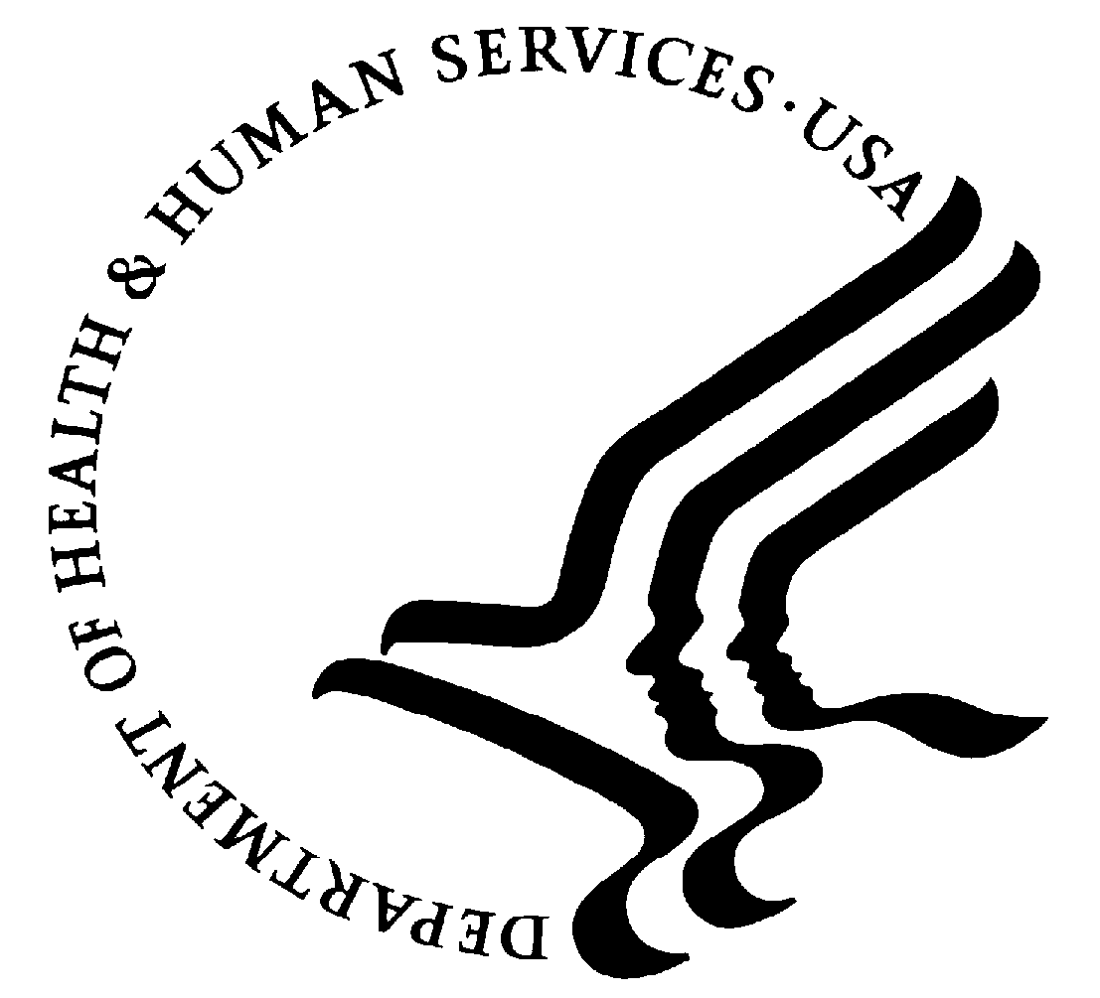 | DEPARTMENT OF HEALTH & HUMAN SERVICES | Public Health Service
National Institutes of Health/ NCI
9609 Medical Center Drive, Suite 530
Rockville, MD 20852
Office (240) 276-5530
Facsimile (240) 276-5504

August 24, 2020

James Love
Knowledge Ecology International
U.S. Mobile +1.202.361.3040
U.S. office phone +1.202.332.2670
http://www.keionline.org

Mr. Love:

Thank you for providing comments to the August 5, 2020 Federal Register notice regarding the prospective exclusive license of E-003-2014 technology to PreciThera, Inc.

The comments in the communication of August 20, 2020 will be seriously considered as they are in every exclusive license from NIH. Our approach has been explained multiple times in past correspondence between the NIH and your organization. Please refer to our previous answers.

Best regards,

Martha T Lubet

Martha T. Lubet
Technology Transfer Manager
Technology Transfer Center NCI/ NIH
Phone: 240 276-5508
Mailing Address:
NCI Technology Transfer Center
9609 Medical Center Drive Office 1E448 Mail Stop 9702
Rockville, MD 20850

