Financing the Accelerated Development of Vaccines for AIDS, TB, and Malaria:
Design of the PDP Financing Facility and an Analysis of Its Feasibility
A Report to Aeras, IAVI, and MVI
February 27, 2009

Executive Summary
Product Development Partnerships (PDPs) have revitalized the search for drugs, vaccines, and other health technologies for the developing world. These partnerships have been strongly supported by OECD governments, foundations, and other donors, but they will need more funding in coming years for expensive late-stage clinical trials as well as expanded discovery research to replenish their product pipelines. In relation to these needs, current financing for the PDPs is too short-term, insecure, and inflexible.
In mid-2008, the three leading vaccine PDPs—the Aeras Global TB Vaccine Foundation (Aeras), the International AIDS Vaccine Initiative (IAVI), and the Malaria Vaccine Initiative, a program of PATH—set up a technical working group to explore innovative ways to finance the three PDPs. This group decided in September 2008 to analyze in greater depth the idea of augmenting grants to the PDPs with government-backed bond financing. Over the past five months, the technical group has worked to develop the proposal, currently called the PDP Financing Facility (PDPFF), adapt it to the needs of the three vaccine PDPs, and explore its feasibility, potential benefits, and costs. This report presents the results of that analysis.
The fundamental rationale of PDPFF is to make available to the PDPs today, through government-guaranteed loans, some of the economic and social value that their work will create in the future. Proceeds from the sale of bonds in private capital markets would be used to support R&D and then repaid when vaccines developed by the three PDPs came to market. The funds to repay bonds would derive from a combination of royalties on sales in high- and middle-income countries and donor-funded premiums linked to sales of PDP vaccines in low-income countries. To reduce risks to bondholders and allow PDPFF to borrow at low interest rates, the Financing Facility would back its borrowing with guarantees from donor governments and possibly foundations. See Figure 1 for a simplified representation of the PDPFF mechanism.
The proposed mechanism raises many questions that would have to be answered before it could be formally endorsed by the PDPs or by donors. The working group has tried to answer some of these questions, although in many cases the answers are still preliminary and require further analysis and discussion.

What are the most important innovative features of the PDPFF, and are they all necessary?
The PDPFF represents a significant departure from the current system for financing the PDPs:
- Donors would support PDPs by providing guarantees and by committing to pay premiums on PDP products when they reach market, as well as through traditional grants.
- Revenues from sales of PDP products would play a much more important role in PDP financing than in the current system.
- The new mechanism would require a greater degree of collaboration among the three PDPs. Revenues from royalties and premiums would be pooled to repay debt, and the three PDPs and donors would agree on an initial expenditure and allocation plan.

Although it might be possible to modify one or more of these features, the technical group believes that all three are necessary for the proposed mechanism to succeed.

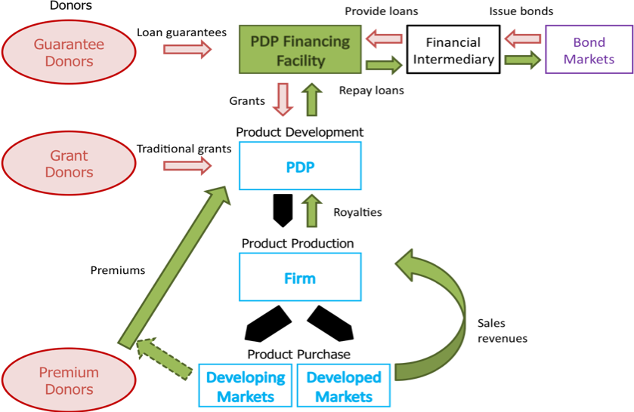
Figure 1: Overview of the PDPFF mechanism
How would PDPFF borrow?
For PDPFF to access capital markets cheaply and efficiently, we propose that it seek to do so through an institution that already borrows in the capital markets in large quantities and at low rates. The most appropriate entity would probably be one of the arms of the World Bank or possibly another multilateral development bank, which would pool the donor guarantees and carry PDPFF’s debt obligations on its own balance sheet. With such a structure in place, PDPFF would request loans from the intermediary and disburse the proceeds to the PDPs as grants to cover eligible R&D expenditures. The loans would be structured to match the circumstances of the PDPs. Interest would be capitalized into the loan during an initial phase when no revenues are coming in, followed by an amortization of principal and interest in later years, when the PDPs’ products are expected to come to market.
How would PDPFF allocate funds and what kinds of expenditures would it support?
Both the PDPs, whose revenues would be pooled to repay PDPFF’s debt, and the donors, who would be liable for this debt if revenues did not materialize, have an interest in how the funds are used. The PDPs also have varied needs (e.g., for applied research, early and later stage trials). We propose an allocations system based on:.
- An initial expenditure plan covering the first 10-15 years and agreed up front among the PDPs and the donors providing guarantees
- Clear rules and decision-making processes governing subsequent reallocations within and between PDP expenditure programs, in response to changing priorities and circumstances
- Some restrictions on eligible expenditures or limits on funding for certain activities
- Ceilings on the share of resources that individual PDPs could receive
How would royalties and premiums work?
Royalties on sales in high- and middle-income countries would be embedded in agreements between individual PDPs and industrial partners who take PDP vaccines to market. Since the royalties that PDPs could obtain would depend on their contribution of intellectual property and capital, among other factors, royalty obligations to PDPFF could take several forms, including (a) a single, across-the-board royalty rate; (b) a schedule of rates based the relative contributions of the PDP and its industry partner; or (c) a fixed share of income from royalties as well as other sources (licensing of IP, services for hire, etc)
Premiums would be payments by donors to PDPFF linked to sales of PDP vaccines in low-income (or GAVI-eligible) countries. These payments could also be incorporated into contracts with industrial partners, but only if donors had committed to paying the additional cost at the time of product purchase. Alternatively, donors could commit to paying premiums directly to PDPFF.
Would these revenues be sufficient?
The technical group modeled potential revenues from royalties and premiums for a portfolio of hypothetical PDP vaccines on the basis of demand and price projections provided by the three PDPs and a number of scenarios for product success or failure. Total revenues were estimated to range from $2.2 to $6.9 billion over the period from 2010 to 2040; discounted at 5%, the net present value of revenues was $0.9 to $2.3 billion. These estimates are unavoidably uncertain, but they suggest that revenues could be sufficient to allow PDPFF to meet a significant share of the PDPs’ expected financial requirements. It could, for example, provide each PDP with $29 to $73 million annually for 15 years.
How would PDPFF be structured and governed?
PDPFF would have a small secretariat responsible for managing loans from the financial intermediary, disbursements to the PDPs, monitoring PDP progress, and reporting to donors. Some of these functions could be carried out on a part-time basis by existing PDP staff, but other tasks, including CFO and auditing responsibilities, would require personnel independent from the PDPs. PDPFF would be governed by a small board comprising representatives of the PDPs and donors as well as independent experts. The composition of the Board and ways to keep the operations of the PDPFF secretariat streamlined and inexpensive merit further analysis.
What would be the benefits of PDPFF to PDPs, donors, and developing countries?
PDPFF could be a substantial new source of secure and long-term funding for the three PDPs, enabling them to expand their R&D programs and accelerate progress toward badly needed AIDS, TB, and malaria vaccines, which could in turn save millions of lives in developing countries. The greater security of funding through the PDPFF would allow the PDPs and their partners to plan activities and investments with greater confidence that the necessary funding would be available.
By providing a way for royalties on sales in more affluent markets to partly offset product development costs, PDPFF could reduce the financial burden of vaccine development on donors. Moreover, the premium mechanism offers a way for donors to support vaccine R&D while paying only for success.
What are the major risks and unanswered questions?
The proposed PDPFF mechanism presents a number of risks:
- Revenues from royalties and premiums could be less than projected and prove insufficient to repay the loans. If donors lack confidence that the loans to PDPFF can be repaid from these revenues, they may be reluctant to provide guarantees, in part because they would need to “provision” the guarantees heavily, setting aside funds in current budgets. This issue will have to be explored further with potential guarantors.
- Royalties at the required rate may prove difficult to negotiate with industrial partners, and an obligation to pay royalties could deter some firms from working with the PDPs.
- The World Bank may be unable or unwilling to serve as a financial intermediary.
- The three PDPs may have trouble agreeing on allocation and governance arrangements and may be unwilling to accept the joint decision-making PDPFF would require.
- The establishment of PDPFF might lead some donors to cut back on grant funding to the three PDPs. The impact of the PDPFF on such grants is difficult to predict, but could be explored through discussions with donors.

Conclusions and next steps
The technical group considers the PDPFF to have considerable promise but recognizes that many important questions remain. Although the group has proposed answers to several of the more difficult design and feasibility questions, further progress on these issues will require consultations with prospective donors and other stakeholders. Therefore the group recommends that the next step, if the three vaccine PDPs decide to pursue this initiative further, should be to open discussions with selected potential donors and with the World Bank.
Financing the Accelerated Development of Vaccines for AIDS, TB, and Malaria:
Design of the PDP Financing Facility and an Analysis of Its Feasibility
A Report to Aeras, IAVI, and MVI
February 27, 2009

Introduction: origin and rationale for this report

Product Development Partnerships (PDPs), created to fill the void left by insufficient industry investment in new drugs and vaccines for the diseases of the developing world, now play a major role in conducting, organizing, and promoting research and development (R&D) toward these urgently needed technologies, including AIDS, TB, and malaria vaccines. While the PDPs have been well supported financially in their first years of operation, in general funding for the PDPs remains inadequate, short-term, and insecure.

To address this problem, in mid-2008 the three leading vaccine PDPs – the Aeras Global TB Vaccine Foundation, the International AIDS Vaccine Initiative, and the PATH Malaria Vaccine Initiative – created a small technical group composed of consultants and senior staff. The group drew upon earlier work by IAVI that looked at a wider range of possible innovative financing mechanisms. These included the use of existing international health funding pools such as the GAVI Vaccine Fund and the Global Fund for AIDS, TB, and Malaria to support vaccine research—an activities that these institutions have not so far funded; a second generation of Advance Market Commitments targeted at early stage vaccines; and several private capital markets solutions.

While all of these options had attractive features, the IAVI analysis suggested that most were unlikely to materialize at this stage for political or economic reasons. In the case of GAVI and the Global Fund, for example, it was judged that the boards of the two organizations were unlikely at this time to support broadening their mandates beyond funding vaccination and infectious disease control services to new product R&D.

For these reasons, the technical group chose to pursue in greater depth one particular idea which had been proposed by Christopher Egerton Warburton, a capital markets specialist who had played a central role in the design and launch of the International Finance Facility for Immunization—the option of using government-guaranteed bonds, issued in the private capital markets and repaid by royalties and donor-supported premiums linked to vaccines sales, to augment traditional grant funding. A special purpose vehicle (in this report referred to as “the PDP Financing Facility”, or PDPFF), created to manage this debt, would pass on the bond proceeds to the PDPs themselves in the form of grants over a period of a decade or more, to support research and development.

This report summarizes the findings and recommendations of the technical group on the PDPFF. While the proposed mechanism could in principle incorporate additional PDPs, this report focuses on an initial structure that includes only the three major vaccine PDPs.

Part I: Background

- The need for AIDS, TB, and malaria vaccines

AIDS, TB, and malaria account for a significant share of the global burden of disease, and count among the top communicable illnesses in the developing world. Two million people died from AIDS in 2007, despite growing access to treatment, and almost three million more became infected. Around a billion people are currently exposed to the threat of malaria, and about 250 million cases and a million malaria-related deaths occur each year. Tuberculosis leads to almost two million deaths annually, despite vigorous efforts to expand case detection and treatment, and the spread of HIV (which favors the onset of tuberculosis by weakening the immune system) creates an additional challenge to effective control of the disease.

While efforts to prevent AIDS, TB, and malaria now receive substantial support and funding from governments and aid agencies and are making some progress, currently available prevention tools for the three diseases are inadequate. HIV prevention today relies heavily on behavior change, which is hard to achieve and sustain. TB control, which currently focuses on early detection and treatment of infectious cases, has been hindered by poor case detection and lengthy treatment regimens and by the spread of drug resistance and HIV-TB co-infection. Malaria prevention efforts have recently been given a boost by the expansion of programs to distribute insecticide-impregnated bed nets, but nets alone will not stop the spread of malaria.

For each of the three diseases, an effective vaccine would constitute the most powerful tool for achieving decisive and sustainable progress. Recent modeling has shown that a million HIV infections could be avoided annually if we had a 50 percent effective first generation vaccine. For each million persons in malaria endemic countries of Africa, a partially effective malaria vaccine could avert 10,000 deaths and 16,000 severe cases over a 20-year period. A tuberculosis vaccine for infants based on an improved and more potent version of the currently available BCG product, followed by periodic booster vaccines later in a person’s life, could similarly strengthen protection against TB infection and avoid hundreds of thousands of TB deaths each year.

- Why the traditional R&D system has not worked for these vaccines

The private pharmaceutical industry has generally taken the lead in vaccine development, making the necessary large investments in pursuit of markets in industrialized countries. This innovation system has delivered many important vaccines, including recent vaccines against human papilloma virus (the cause of cervical cancer), pneumococcal bacteria, and rotavirus (the cause of severe and sometimes life-threatening diarrheal disease). The system has not worked as well, however, to develop vaccines for diseases such as AIDS, TB, and malaria that primarily affect developing countries.

Although several firms have invested in vaccines against AIDS, TB, and malaria, most of these efforts have been on a relatively small scale, reflecting the judgment that the scientific risks are too high and market prospects too dim or uncertain to justify full-scale commercial investment. While lack of purchasing power is the primary problem, unfamiliarity with low-income country markets, fear of public pressure to sell at very low prices and other concerns also discourage private investment in R&D for these vaccines.

Thus the pull of existing markets has not proven sufficient to drive private investment in AIDS, TB, and malaria vaccine R&D on the required scale. Governments and foundations, recognizing the urgent need for these vaccines, have over the past decade attempted to compensate for insufficient private investment by funding research and some product development activities directly (for example, through the NIH’s Vaccine Research Center) and by supporting non-profit Product Development Partnerships (PDPs).

- The establishment and role of the PDPs

Since the mid-1990s, the PDPs have emerged as an important vehicle for advancing R&D into these urgently needed new health technologies, including neglected disease drugs and diagnostics as well as vaccines. The PDPs, which are funded primarily by governments and foundations, in turn finance R&D in their own facilities and through partnerships with biopharmaceutical firms, research institutes, and university laboratories. The PDPs are thus both implementers of vaccine R&D and financing intermediaries, managing a portfolio of discovery research projects and vaccine candidates and monitoring the R&D activities of their partners. The PDPs constitute an important mechanism for engaging the expertise of the private sector in the development of new health technologies and channeling resources toward the most promising research.

As a group, the PDPs have shown considerable promise in accelerating R&D at various stages of the pipeline, including product discovery, preclinical and clinical trials, and in some cases product registration and introduction. Although a handful of new drugs supported by the PDPs have now been licensed, the three key PDPs focusing on vaccines are all still some years from bringing a new product to market.

- Current vaccine PDP funding

The three main vaccine PDPs – Aeras, IAVI, and MVI – have all grown rapidly in recent years. In 2007 their combined expenditures reached $161 million (Table 1). While the PDPs receive financial support from a wide range of institutions and individuals, most of their current funding comes from two sources: the Bill & Melinda Gates Foundation, which accounted for 43% of revenues for the three PDPs in 2007, and OECD governments (the largest being the US, Canada, the UK, and the Netherlands) which contribute another 54%. The mix of financing from these sources varies from one PDP to another. PDP funding from governments comes primarily from overseas development aid agencies rather than from national medical research organizations, as the latter tend to focus on financing basic research conducted by their own national scientists. The typical term of grants to the three PDPs is 3-5 years.

Table 1: Aeras, IAVI, and MVI Expenditures and Financing

 | Aeras | IAVI | MVI | Total
2007 Expenditures ($US millions) | 44 | 84 | 33 | 161
2007 Revenues | 42 | 92 | 40 | 174
Share OECD governments | 27% | 89% | 2% | 54%
Share Bill & Melinda Gates Fdtn | 72% | 6% | 98% | 43%
Share Others | 1% | 5% | <,5% | 3%
Weighted average grant term | 5.2 years | 3.8 years | 4.5 years | 4.3 years

- Gaps and deficiencies in the current system for financing the PDPs
Donor government and foundation grants have enabled the vaccine PDPs to launch significant R&D programs and to advance multiple vaccine candidates to clinical trials. But this system has a number of drawbacks, and it faces new challenges in the coming years.
Insufficiency
First, the current level of grant funding is insufficient to cover projected needs in the medium- to long-term. The PDPs with vaccine candidates in more advanced development, particularly Aeras, face the prospect of paying for large Phase III efficacy trials at a cost of over $120 million per vaccine candidate. At the other end of the R&D spectrum, each of the three groups recognizes a need to replenish its pipeline through expanded discovery. In the case of AIDS vaccines, IAVI and other organizations in the field are giving increased priority to large-scale applied research focused on the scientific challenges that have impeded development of viable vaccine candidates. As a new generation of candidates emerges, further funds will be required to meet their development costs.
Insecurity
Even if current levels of funding were sufficient for future needs, continued funding at current rates is by no means assured. Almost all funding comes in the form of short to medium term grants, typically covering 3-5 years, yet vaccine development is an inherently long-term undertaking. Overcoming the scientific challenges will require sustained effort, and even when promising candidate vaccines have been developed, moving them through preclinical and clinical testing, manufacturing process development, scale-up and licensure takes more than a decade. Although donor support is currently strong, future funding may be affected by shifts in priorities and financial circumstances such as the ongoing global financial crisis. This unpredictability impedes long-term planning and potentially discourages involvement of the private sector.
Fragmentation or excessive reliance on a single donor
For IAVI, as for some of the drug PDPs, funding comes from many donors. Although diversity of funding sources can be an important hedge against changes in individual donor priorities, managing grants from multiple funding agencies, each with its own requirements and timelines, imposes additional costs and inefficiencies. Some other PDPs, including Aeras and MVI, face the opposite problem of almost exclusive reliance on a single donor, the Bill & Melinda Gates Foundation. The generosity and vision of the Foundation has transformed the landscape of neglected disease R&D, but it alone will not be able to fund all of the PDP’s current projects to completion. The Foundation therefore has strongly encouraged the PDPs to seek other sources of financing.
Inflexibility
Finally, current funding streams are often insufficiently flexible. R&D priorities change, and restricted funding can hinder the ability of the PDPs to rapidly reallocate funds to new activities. In the case of AIDS vaccines, for instance, the disappointing outcome of the Merck trial in late 2007 has led to a consensus in the field that a greater share of resources should go to applied science and other earlier-stage activities, with fewer candidates entering clinical trials in the next few years. Yet much of IAVI’s funding comes from development donors, who historically have preferred to fund activities that take place in developing countries, such as clinical trials, rather than laboratory science, much of which to date has been conducted in the United States and Europe.

Part II: Design and function of PDPFF
- Summary description of PDPFF
The PDP Financing Facility would constitute a new mechanism for funding Product Development Partnerships. The facility would be designed to provide new, long-term resources for R&D by making available to the PDPs today some of the economic and social value that their work will create in the future. While the mechanism has been designed initially for the three leading vaccine development partnerships – Aeras, IAVI and MVI—it could in principle be extended to include a range of PDPs. The analysis presented here focuses on the three vaccine PDPs.
The new mechanism would augment current grant funding with loans backed by a portfolio of guarantees obtained from sovereign donors. With these guarantees in hand, PDPFF could in theory borrow directly in bond markets. But for a variety of reasons it would preferable to have one of the Multilateral Development Banks serve as an intermediary, which would borrow in the capital markets using its own balance sheet and lend in turn to the PDPFF. The Facility would then disburse the loan proceeds in the form of grants to the participating PDPs for eligible R&D activities.
The loans to the PDPFF from the intermediary would be repaid by royalties or premiums attached to products developed by the PDPs. Royalties, which would be incorporated into agreements with industrial partners who bring these products to market, would apply to sales in high and middle-income countries, where they would allow PDPFF to capture some of the commercial value generated by the PDPs. Premiums on sales in low-income countries would be paid by donors or by donor-funded health financing mechanisms like GAVI or the Global Fund that already subsidize purchase of drugs and vaccines in these countries. In this way, some of the expected returns from future PDP vaccines would be made available to fund PDP R&D today. From a donor’s perspective, provision of loan guarantees and payments for actual products at the time of delivery would augment (although not replace) up-front grants as a means of subsidizing product development. See Figure 1 for an overview of the proposed mechanism.

Figure 1: Overview of the PDPFF mechanism

All cash flows into PDPFF, regardless of their source, would be used to reduce the Facility’s outstanding debt—revenues generated by the products of one PDP could be used to repay debt incurred to pay for another’s expenditure. The risk to donors will thus be reduced by a portfolio effect: the projects of the PDPs face largely independent risks, and high-risk/high-return projects like AIDS vaccines will be balanced by projects like improved TB vaccines with relatively lower risk of failure and more modest revenue prospects.
At the time PDPFF is established and loan guarantees are provided, guarantors (OECD governments, possibly foundations) and PDPs would agree on the activities that PDPFF would support, as well as the allocation among PDPs. Since the specific needs of the PDPs cannot be forecast in detail over the entire lending period, a set of criteria would be established by which PDPFF could approve reallocations between activities and, in some circumstance, between PDPs.
The initial proposal to donors would also show how funding from PDPFF would blend with other funding streams and be drawn over time, and in broad terms how the loans would be repaid as PDP products come to market. As the three PDPs have different needs and their products have different potential for sales in low- and high-income markets, these projections would vary substantially among the PDPs.
The PDPFF would have a small secretariat whose functions would include borrowing from the intermediary institution, disbursing grants to the PDPs, and routine monitoring and reporting. Some of these functions could be carried out by existing staff from the member PDPs, but some key positions, including a CFO and an auditor, would probably have to be independent of the PDPs in order to maintain neutrality.
PDPFF would be governed by a small Board composed of representatives of the participating PDPs, representatives of the donors providing guarantees, and independent experts familiar with vaccine development and the PDPs. This Board, possibly advised by an independent technical committee, would be responsible for approving the disbursements to individual PDPs and for adjusting allocations to the PDPs as circumstances change over time. The degree of discretion exercised by the Board would depend on the extent to which these allocations are specified in advance and on whether additional guarantees are obtained after PDPFF is launched.
The Board would also be responsible for overseeing the overall financial performance of PDPFF. This would require monitoring the progress of the various PDP products in development and evaluating the evolving risks to repayment of its debt.
It would make sense to design PDPFF in such a way that it could be expanded over time to include other PDPs engaged in the development of new vaccines, drugs, and diagnostic tests. We have not attempted to analyze how such an expansion, which would involve the addition of new donor guarantees and new prospective revenues to the pool, would be managed.
- How PDPFF would borrow and disburse
Donor guarantees. The capital base of PDPFF would be a portfolio of guarantees from donor countries (and possibly foundations). These guarantees would commit the guarantors to repay a quantum of PDPFF’s debt, if outstanding at the maturity of the loan. In order to ensure that all guarantors rank equally, it is proposed that guarantees from different donors follow the same maturity profile. These maturities could be spread over a number of years, for example between 2020 and 2040. It is not essential that all guarantees start on the same day; in principle, new guarantors could join or top-up their guarantees once PDPFF is established.

The guarantees would be provided in order to allow PDPFF to borrow and utilize the proceeds to support the research programs of the participating PDPs. Like grants, the guarantees would be given subject to certain conditions regarding the use of funds and reporting, although the funding program would cover a much longer period than conventional grants. As discussed in the next section, the expected uses of the funds would be outlined in an initial plan prepared by the PDPs and agreed with the donors.

Role of a Multilateral Development Bank. With donor guarantees in place, PDPFF theoretically could borrow in its own right from other banks or in the broader capital markets. But setting up an independent borrowing facility would be costly and inefficient, and we believe that it would be preferable to channel borrowing for PDPFF indirectly through a Multilateral Development Bank (MDB). This class of institutions, which includes the arms of the World Bank and the European Investment Bank, among others, is able to borrow at low interest rates because the securities that they issue, like those of G7 governments, are deemed to represent nearly “risk-free” investments.

A further advantage of structuring PDPFF as a captive borrower of an MDB is that these institutions already borrow in large volumes and come to the markets regularly, issuing bonds with a broad range of maturities. This allows investors a high degree of liquidity and flexibility. A borrowing program in the range of $15-20 billion is now deemed necessary to achieve these characteristics. PDPFF, which may need $1-3 billion (see below), is unlikely to borrow on this scale.

The entity that would be the best-suited to serve as an intermediary for PDPFF would be an arm of the World Bank—either the International Bank for Reconstruction and Development (IBRD), which borrows in the capital markets in order to lend to middle income developing countries, or the International Finance Corporation (IFC), which provides loans and equity to the private sector in the developing world. These two arms of the World Bank Group have a mandate complementary to the mission of the PDPs, and relationships with the entire donor network. The European Investment Bank could perform a similar role, but would only be relevant if guarantees came only from European donors.

The World Bank already serves as treasury manager for the International Finance Facility for Immunization (“IFFIm”), designing and executing its funding strategy. IFFIm does borrow in its own name; however, it was created with view that it could expand substantially beyond its current projected program of $4 billion. In the event that the World Bank or another MDB agreed to work with PDPFF, we would propose that it go beyond the treasury manager role and fund the PDPFF directly from its own balance sheet. Under such an arrangement, PDPFF would borrow under a pre-arranged facility directly from the MDB, which would then fund that commitment by issuing its own debt in international capital markets.

Under the IFFIM model, WB is paid a fee on a cost-recovery basis for the treasury services Under PDPFF model, the MDB could be simply repaid via a spread over its cost of funding. This would be consistent with its standard lending terms and conditions.

We have not yet been able to ascertain clearly whether the World Bank would be willing or able to play the role that we outline here, which would represent a departure from the traditional roles of either the IBRD or the IFC. This issue is discussed in Section IIIB.

Grants from PDPFF to the individual PDPs and loans from the MDB. Once the PDPFF has obtained guarantees and established a loan facility with an MDB, it would be in a position to borrow the necessary funds and to make grants to the PDPs. Interest would be capitalized into the loans during an initial phase, for example to 2020, during which period the PDPs will have few products on the market and thus little revenue to help repay the loans, followed by an amortization of principal and interest (a mortgage-style repayment) from 2021 to 2040, when the PDPs’ products might be expected to generate significant revenues. If all loans are provided on the same basis, it will not matter when a specific loan commences or is disbursed—all will effectively accumulate into a single pooled obligation of PDPFF. New loans could be granted after 2020 under this structure, but these loans would not have a period of interest capitalization.

Effectively each donor guarantee would lead to a series of loans from the MDB and corresponding grants to the PDPs, according to a pre-agreed schedule. Each PDP would know how much “capacity” they had under their respective program, whilst each donor would know the maximum exposure they would incur when funding under the program is fully drawn. Assuming that grants are taken over time, the capacity of PDPFF will fluctuate with changing interest rates. However, the impact can be reduced by fixing the interest rate of each new loan as it is taken by PDFPP.

How this would work in practice. Let us assume that a PDP is planning its annual expenditure program in some year after the establishment of PDPFF. It creates a budget employing its own funds (from grants and donations) and funds from PDPFF.

The PDP would then request from PDPFF the draw-down of these additional funds under the guarantee facility agreed with the donors. Assuming that the PDP still had capacity under its facility (i.e. had not used up its capacity in earlier years) and that the use of proceeds were consistent with any provisions under which the donor guarantees were made, the Board of PDPFF would authorize the new withdrawal.

Simultaneously, the Board of PDPFF would apply to its MDB for a loan with identical disbursement terms to the grant agreed with the PDP. In this way the PDPFF would have no liquidity risk (no significant cash balances). The MDB would commit to provide PDPFF with the necessary funds on the agreed dates, add these disbursements to its overall funding needs for the year, and adjust accordingly its borrowing on capital markets.

For a graphical representation of these transactions, see Figure 2.

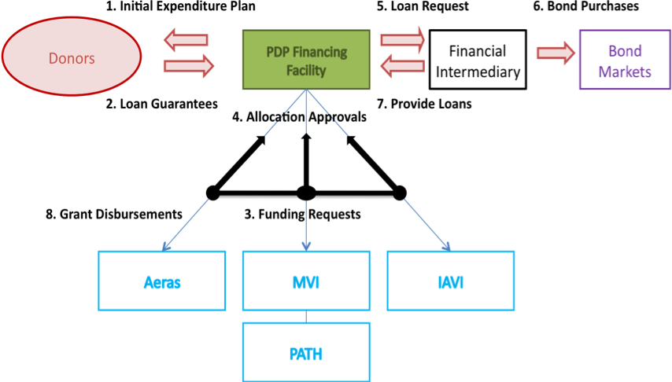

Figure 2: Transactions among donors, PDPFF, the financial intermediary, and the PDPs during start-up and operation of the facility.

Managing currency risk. As the PDPs all prepare their accounts in US dollars, we propose that PDPFF borrow and disburse exclusively in US Dollars. It would therefore be easiest if all guarantees were provided in US Dollars. If this were not possible, then suitable hedging arrangements would be put in place at the time the guarantees are made.

- How PDPFF would allocate its funds

The proceeds from donor-guaranteed loans to PDPFF from the World Bank (or another MDB) would be used to support the R&D activities of participating PDPs. In determining which activities would be eligible for PDPFF funding and how these decisions would be made, a balance must be struck between the interest of donors in having some control over what activities their guarantees would support and preserving prospects for repayment, and the interest of the PDPs in setting their own research priorities and in retaining the flexibility to change course in light of research developments. Moreover, individual PDPs would want some assurance that the allocation of PDPFF funds (if coupled to a reduction in grant funding) would not leave them worse off than they would be without the new initiative, and that the mechanism would serve their particular purposes. These occasionally divergent interests cannot be completely reconciled in this report—this will require detailed negotiations among the three PDPs and between the PDPs and prospective donors—but we propose here four general elements of an allocation system that we hope could serve as the basis for successful agreement.

1) Initial expenditure plan. There is general consensus in our group that donors would not agree to provide guarantees without a fairly detailed expenditure plan. This plan, negotiated among PDPs and donors, would lay out the major R&D activities that each PDP would support using PDPFF funds over perhaps a 10 year-period, and the rationale for these expenditures. This plan could also sketch out in broad terms the overall financial needs of each group over this period and how these needs would be met by a combination of PDPFF resources and conventional grant funding.

2) Rules for reallocation within and among PDPs. Research and product development are inherently uncertain, and it is inevitable that there would on occasion be good cause to revise expenditure plans after the PDPFF is up and running. There revisions could reflect changes in the timing or amount of anticipated spending on already included projects, as well as shifts in priority from one candidate vaccine or discovery program to another, from early- to late-stage projects or vice-versa, or from one PDP to another with more immediately pressing needs. Therefore PDPFF must have mechanisms for reallocating funds, but these mechanisms must again balance the need for flexibility with the interests of donors and individual PDPs. Reallocation decisions would be made by the board of PDPFF (or a committee established by the board for this purpose—see Section E) according to agreed rules. We will not attempt to lay out these rules, but suggest that reallocation from one stage of R&D to another should be more difficult than reallocation among similar projects (such changes might require a larger majority of the committee or more stringent evidence), and reallocation between PDPs would be considerably more difficult than reallocation within a PDP (allocation from one PDP to another might require unanimous approval, for example).

In addition to scientific merit and the interests of the three PDPs, reallocation decisions should take into account the interests of donors, including their interest in preserving prospects for loan repayment. This interest could be protected by donor representation on the board of PDPFF (see Section IIE) as well as by a requirement that PDPs requesting reallocation address the implications for future revenues.

3) Restrictions on eligible expenditures. Our technical group considered the possibility of limiting the use of PDPFF funds to late-stage clinical trials. In this way the Facility could ensure that only projects with a relatively high chance of success were supported, while simultaneously limiting the scope (and associated transaction costs) of allocation decisions that PDPFF might face in the future. While such a restriction would accord well the projected financing needs of at least one of the three PDPs, Aeras, it would make the initiative less attractive to another PDP with significant future expenditures on applied research, IAVI. As a compromise, we suggest imposing a ceiling on the share of total PDPFF funds that could be spent on discovery and other early-stage R&D. The majority (the precise breakdown is left for further discussions) of the funds would be reserved for efficacy trials, including both Phase 3 licensing trials and the smaller Phase 2B and, for IAVI, STOC trials. The PDPs and donors may want to consider other restrictions on eligible expenditures.

4). Restrictions on PDP shares. We propose furthermore that the share of the available funds (as determined by the sum of donor guarantees) that each PDP could receive also be subject to a ceiling specified in the agreement establishing the PDPFF, although this limit could be raised by agreement of the other PDPs. Among the factors that could be considered in setting these ceilings—and shares in the initial plan—are anticipated suitable uses (promising and eligible R&D activities), availability of other funding (and risks to this funding as a result of establishing PDPFF), and the estimated contribution of each PDP’s products to PDPFF’s revenues. PDP ceilings could add up to 100% or somewhat more; limits totaling more than 100% would leave some room for reallocation.

These restrictions on eligible expenditures and on PDP shares would be reflected in the initial expenditure plan and in the rules for reallocation. Together with the initial plan and the reallocation rules, they would substantially limit the scope of decisions that PDPFF would have to make once it is established and thus its governance challenges.

An illustrative spending plan
To give some sense of when PDP funds might be used, on the assumption that these funds are used only for efficacy trials, we modeled expenditures for Phase 2B and 3 trials associated with the development of a set of eight potential vaccines from the three PDPs. These hypothetical expenditures totaled $2.8 billion over 18 years. In net present value terms (with a 5% discount rate), this comes to about $2.0 billion in 2010, toward the higher end of our range of estimated revenues discounted to the same year. These expenditures and revenue streams are plotted in Figure 3 at the end of the next section. For more detail on this analysis, see the Annex.

- How loans to PDPFF would be repaid

PDPFF would derive revenues from two sources, royalties on sales of PDP vaccines in high- and middle-income countries and premiums linked to sales of vaccines in the poorest countries. These revenues streams would either flow directly to PDPFF or be forwarded immediately to it upon receipt by the PDPs; this obligation would be a condition of receiving grants from the Facility. PDPFF would then use these revenues to repay outstanding loans from the financial intermediary (see below for discussion of a situation in which revenues exceed outstanding debt).
Royalties. Royalties are payments linked to sales of qualifying vaccines in covered countries, made to PDPFF by the entity that brings a PDP vaccine to market.

- Qualifying vaccines would be those to the development of which participating PDPs have contributed significantly, that is, the vaccines that constitute their “portfolios”. It may be necessary to exempt a small number of vaccines that are already in advanced development at the time PDPFF is established, since it would in general be difficult to revise agreements with partners at such a late stage.
- Royalties from PDP product purchases would be owed to PDDFF whether or not the development of a particular vaccine was supported by the funds from the Facility. Such a blanket obligation would eliminate any incentive for a PDP to use the bond funds to support less promising candidates, allowing it to seek conventional grant funding for the likely “winners”, a practice which would threaten future revenues to the PDPFF.
- Covered countries would be middle- and high-income countries, except those middle-income countries that are eligible for GAVI support.
- In general, royalties would be paid by for-profit pharmaceutical companies, since these firms are likely to bring most PDP vaccines to market, especially in high-income countries. But if a PDP should choose to register and market a vaccine on its own, it would be responsible for paying the royalties to PDPFF.
- We have modeled royalties as a fixed percentage of sales revenues, but more complicated formulae are possible. Royalty rates could differ between middle- and high-income countries, and possibly also according to the nature of the PDP’s contribution to development of the product (see below).
The obligation to pay royalties would be embedded in contracts between PDPs and industrial partners. Since royalties are a standard feature of product development contracts in the private sector, the addition of royalties to agreements between PDPs and their partners requires no new legal or institutional machinery. However, there is a risk that royalty obligations, if too high, could discourage firms from entering into agreements with PDPs.. We discuss this issue in Section IIIB.2.
Every negotiation between a PDP and a prospective industrial partner is different. The stage of development of the candidate vaccines, the past and anticipated future contribution of intellectual property and capital contributed by each partner, and the commercial prospects of the product if it comes to market can all differ greatly. The difficulty of incorporating a royalty obligation in these agreements will differ accordingly. Given this diversity of circumstances, how should the PDPFF obligation be structured? We propose three alternatives.
Option 1: Fixed-rate royalty applying to all PDP vaccines. Under this approach, if a PDP were unable to impose this rate for a particular vaccine candidate, it would have to commit to making up the shortfall from higher royalties on other vaccines or from other sources. This is in many ways the most straightforward approach, and it would set clear expectations and remove an important source of uncertainty about future revenues. Enforcing this requirement could be difficult, however, as donors providing grants to the PDP’s may be unwilling to make up the difference if the required revenue rates could not be negotiated successfully.
Option 2: Royalty rate table. Alternatively, the royalty obligation could vary with the nature of the partnership according to a taxonomy of agreement types and circumstances. For example, rates would be higher if PDPs had developed the candidate vaccine from early stages and were prepared to pay for clinical trials, lower if the candidate were developed by the firm and trial support were the PDP’s primary contribution. This approach has the advantage of taking the diversity of circumstances into account but would require agreeing on the category into which each partnership fell. Moreover, the problem of what to do if the target rate could not be negotiated would remain.
Option 3: Fixed percentage of all income. Another approach would be to require PDPs to pass on to PDPFF a fixed percentage of all income, from royalties as well as from other sources such as licensing of IP. This option would sidestep the problem of anticipating what agreements with firms will bear, as well as the difficulty of defining which vaccines constitute a PDP’s portfolio (how large does the PDP’s contribution have to be to qualify?). On the other hand, this approach would make it difficult to know in advance how much revenue PDPFF could expect, and might not give PDPs sufficient motivation to push for higher royalties.
Choosing among these (and potentially other) royalty structures and setting a target rate or rates will require further analysis of the major classes of agreements between PDPs, and, eventually, discussions with industry.
In our revenue projections, we have assumed a fixed royalty rate of 5% of gross sales revenues in both high-income and non GAVI-eligible middle-income countries, valid for 20 years from vaccine launch, but we explore the implications of higher and lower rates. Since vaccine prices will almost certainly be substantially lower in middle-income than in high-income countries, actual per-dose royalty payments associated with sales in middle-income countries (and any corresponding impact on prices) will be lower as well, even if royalty rates are the same.
Premiums. In theory, royalties could also be charged on sales in low-income countries. But since vaccine prices in these markets are low, royalty rates would have to be very high to generate significant revenue. Moreover, a percentage royalty would put the PDPs in the uncomfortable position of benefitting from higher vaccine prices in the countries that could least afford them. As an alternative, we propose a distinct type of payment that we call a premium. Like royalties, premiums would be payments to PDPFF associated with sales of PDP vaccines. However, they would differ from royalties in several important ways.
- Premiums would be linked to sales in poor countries. Covered countries could be low-income countries (as defined by the World Bank), or GAVI-eligible countries.
- Payments would be proportional to sales volume rather than to sales revenues.
- Donors, rather than manufacturers or vaccine recipients (or their governments), would be the ultimate source of funds for premiums, although manufacturers might be responsible for making the actual payments to PDPFF (see below).
Incorporating premiums of this type in the PDPFF proposal has several advantages. First, this second stream of revenue is probably necessary to support borrowing on the proposed scale and to reduce revenue risks. While some PDP vaccines might be widely used in rich as well as poor countries, others have little prospect of developed-world sales and thus of royalties. Including premiums allows PDPs that will not be able to earn significant revenues another way to contribute to bond repayment. Finally, the premium mechanism offers a new way for donors to support PDP R&D (see below).
Unlike royalties, premiums are a new mechanism, and their institutional and contractual basis will have to be established in advance if PDPFF’s lenders and guarantors are to have confidence that this revenue stream will materialize.
Several arrangements are possible. One way to collect revenues is to embed them, like royalties, in contracts between PDPs and manufacturers. These provisions would require firms to pay the agreed amounts to PDPFF on being notified by UNICEF (or GAVI) that an eligible country has purchased their vaccines. Such a solution provides a sound contractual basis for premiums, but it introduces a new issue. Firms, who will presumably increase the prices they charge to poor countries to cover the premium, would resist this new obligation unless they have confidence that GAVI or other donors would pay the additional amount for PDP vaccines.. To allay this concern, it would probably be necessary to obtain from donors some kind of assurance that they would pay the premiums, either directly or through GAVI. As recent experience with IFFIm and the AMC has shown, obtaining formal, legally binding commitments from donors is challenging.
Alternatively, donor countries could commit to paying the premiums directly or through increased contributions to GAVI. This would avoid the danger of deterring firms, but would require formal commitments to give the premiums a contractual basis, with the attendant budgetary complexities. GAVI itself could declare its willingness to pay the premiums, but given GAVI’s dependence on its own donors, such a commitment would carry little weight by itself.
It probably makes sense to limit premium payments to a certain period after product launch—or, more precisely, after the start of sales in GAVI countries. This is because these payments are intended to repay the cost of developing the vaccine. In addition, the price of new vaccines can be expected to fall after they have been on the market for some time, and a fixed premium could therefore become large in proportion to vaccine price. We have assumed in our analysis that premiums, like royalties, are paid for 20 years after vaccine launch.
It has been pointed out that premiums constitute payments from donors to themselves, since these revenues contribute to repaying loans that the guarantors might otherwise be obliged to repay. But it is important to keep in mind that the donors who provide guarantees may not be the same as those who agree to pay premiums, and that the two types of donor contribution offer different ways of supporting new vaccine development (see Section IIIA).
Likely revenues to PDPFF. We have modeled possible revenues to PDPFF in a range of scenarios, taking into account the portfolios of the three vaccine PDPs, likely demand and prices for their vaccines in low-, middle-, and high-income countries, and different royalty and premium rates. We conclude that revenues to PDPFF could range between $2 billion and $7 billion.. Discounted at 5%, these revenues yield a net present value in 2010 of about $1-2 billion (see Table 2). Figure 3 illustrates the flow of revenues over the period from 2010 to 2040 in the “optimistic” scenario, plotted against expenditures if these were limited to efficacy trials. For definitions of the scenarios and details of the analysis, see the Annex.

Table 2: Potential revenues from royalties and premiums
Scenario | Optimistic | Intermediate | Pessimistic | Low royalty
Successful products (of 8 total) | 5 | 3 | 2 | 5
Royalty rate | 5% | 5% | 5% | 2%
Premium rate | $1.00 | $1.00 | $1.00 | $0.50
Total revenues (2010 NPV), $US billions | 2.3 | 1.1 | 0.9 | 1.1
Total revenues, undiscounted | 6.9 | 2.9 | 2.2 | 3.2
Royalty percentage | 34% | 13% | 11% | 29%
Premium percentage | 66% | 87% | 89% | 71%
Aeras percentage | 24% | 51% | 38% | 24%
MVI percentage | 47% | 49% | 62% | 50%
IAVI percentage | 29% | 0.0% | 0.0% | 26%

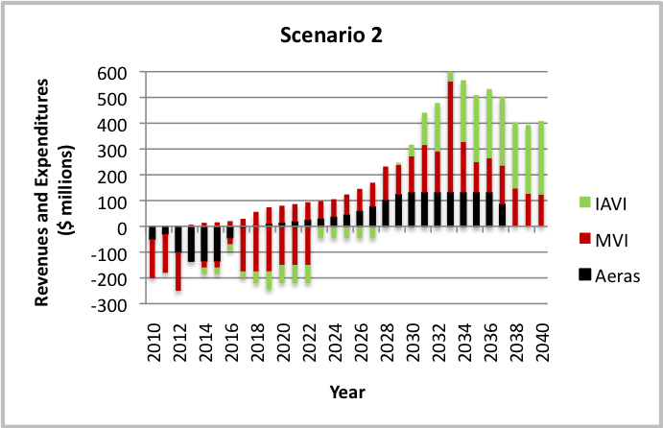

Figure 3: Revenues and expenditures by PDP and year in one scenario

Managing excess revenues. In general, all cash in-flows to PDPFF would be used to reduce its debt. This is appropriate, as the debt has a cost; by reducing the outstanding balance, PDPFF would be able to minimize total interest payments. Donors would also be comfortable that their risk effectively is senior to that of all other parties. However, in some circumstances, for example when long-term contracts to purchase PDP products are in place, it may be possible to foresee with some certainty that revenues would be more than sufficient to repay completely PDPFF’s debt by maturity. In this instance, it may be possible, with the donors’ agreement, for PDPFF to re-leverage itself to a degree, thus bringing forward “excess revenues” for additional R&D spending. How such capital is deployed would be impossible to define upfront, and therefore a mechanism will need to be put in place for PDPFF to make such allocations.

Even if PDPFF does not front-load any “excess revenues”, if all goes well there would be a time before the expiry of PDPFF’s mandate when it will have repaid its debt but cash would still be coming in. Thus it would be necessary to tackle the issue of excess revenues whether or not additional borrowing against these revenues is permitted.

Revenue shortfall. If projected revenues fail to materialize, in contrast, it may become clear at some point that PDPFF would not be able to repay its debt according to the agreed schedule. In this case, the PDPFF would have the option of asking the guarantors to “convert” some of the guarantees to grants, allowing the PDPFF to reduce its debt burden. Failing this, however, the MDB that held PDPFF’s debt would have to call the guarantees, requiring the guarantors to make up the shortfall when the loans came due.

- Structure and governance of PDPFF
PDPFF’s structure, governance, and operating procedures should be appropriate to its mission: to provide long-term and relatively flexible additional financing to the vaccine PDPs. To carry out its mission, the Facility would have to perform the following functions:
- Fund raising. The initial set of guarantees from donors or foundations would be obtained by the three PDPs working in concert or by PDPFF, if it has been established. The PDPFF secretariat and board would be responsible for seeking additional guarantees once the facility is up and running.
- Allocating resources. If the shares of PDPFF’s resources available to each of the PDPs as well as the permitted uses of these funds are largely fixed at the outset, then fund allocation and disbursement would be relatively mechanical. If adjustments are more frequent and involve more judgment and discretion, then PDPFF would need more staffing and effort to carry out this function.
- Obtaining loans from the intermediary and making grants to the PDPs. These Treasury functions would be performed by a CFO/Treasurer who would be responsible for managing the relationship with PDPFF’s lender (the MDB), sending routine requests for loans to cover approved disbursements to the PDPs, and disbursing grants to the PDPs for their eligible R&D activities.
- Repayment of loans. As revenues begin to flow to PDPFF from royalties and premiums, the PDPFF would begin to repay its loans. In general this should be a fairly routine function, but as discussed in the previous section, the Facility might have to take action if it became clear that revenues would be substantially greater or less than required to repay debt.
- Monitoring progress of the PDPs in utilizing their loan proceeds and moving toward marketable products – and reporting back to the guarantors and to the MDB. Guarantor organizations’ managers would want to know whether the PDPs are on track to develop and market new vaccines, and donor accounting and other financial staff would want to assess whether they should be increasing the provisions in their budgets against the likelihood of a guarantee being called. The financial operations of the PDPFF would be subjected to regular independent audit.

PDPFF Secretariat, Board, and Expert Committee. Once fully up and running, PDPFF would require a small secretariat to perform these functions. There would be more work to be done during the start-up phase, when guarantees have to be obtained from donors and a plan for allocating the funds across the PDPs agreed, although whether this work would be carried out by PDPFF would depend on when this entity is established.

PDPFF would keep its staffing, activities, and operating expenditures to a minimum. Some of the Facility’s work could be done on a part-time basis by designated PDP staff, based on an agreed division of labor. One PDP could take the lead on behalf of the others, they could share tasks, and PDPs could perform some functions (e.g., raising guarantees) together. Other tasks, especially treasury functions (requesting loans from the intermediary bank, disbursing to the PDPs) and monitoring would have to be done by an independent group of staff and/or consultants.

The three PDPs would need to develop a Secretariat staffing and work plan for the pre-launch and startup periods of PDPFF, including the levels of independent staff and consultants required as well as the staff contributions from each organization. A lead coordinator or secretary (probably an independent third party) would need to be hired to organize the work and keep it on track.

PDPFF would be governed by a Board that would have ultimate responsibility for key decisions, including the quantity of guarantees to be sought, the allocation of funds, the use of excess revenues (if any), and actions to be taken in the event of insufficient revenues. The secretariat would report to this Board.
Our technical group agreed that the PDPFF Board should be kept as small as possible, but there was some divergence of opinion regarding its composition. Some members of the group felt that PDPFF should be largely “owned” by the PDPs themselves, and that the PDPs should therefore hold a majority of seats on the Board, augmented by a few independent experts. They argued that many donors would prefer this arrangement, wishing to have a hands-off stance toward PDPFF. Donors could exert influence over the utilization of funds by the PDPs through other means, for example by sitting on the boards of individual PDPs.
The predominant view within the group, however, was that many of the potentially important donor sponsors of the Facility would wish to be on the Board and to participate actively in PDPFF decisions. According to this perspective, it would be a conflict of interest for the PDPs themselves, as the primary financial beneficiaries PDPFF, to dominate its Board. According to this view, donor representatives and independent members should comprise a majority of the Board.
We did not attempt to resolve this issue, which will require further discussion among all parties.
Procedures for seeking guarantees and other funds for PDPs. How should PDPFF and the individual PDPs approach donors about guarantees and about traditional grants, which would run in parallel to PDPFF financing?
The PDPs should be as comprehensive and transparent as possible with donors about their expected total financial needs over the medium and long term. We suggest that the three vaccine PDPs develop a long-range financing plan that estimates their combined resources needs and proposes a division between traditional grants and bond funding through PDPFF. This expenditure plan should be accompanied by a forecast of potential revenues from royalties and premiums. With such a plan in hand, the PDPs should together seek loan guarantees for PDPFF from donors. Negotiations on complementary grants to the PDPs would be conducted separately and bilaterally.
Procedures for reallocation of funds and revenues. Although an expenditure plan would have been agreed to at the outset, PDPFF must have the flexibility to adjust allocations as needs change. We recommend that reallocation decisions be made by the PDPFF Board on the basis of advice from an Expert Committee on Allocations. To avoid potential conflicts among the three PDPs on allocation decisions, it might make sense to give a majority of seats on the Expert Committee to independent persons.
Procedures for monitoring, reporting, and auditing. The PDPFF secretariat would be responsible for regularly collecting information from the PDPs (progress in science and product development, financial operations, revenues and revenue prospects) and reporting this information to the donors and to the public, along with updates on the deliberations and recommendations of its Expert Committee on Allocations and the decisions of its Board. The PDPFF’s own financial operations would also be subject to regular independent audit. The secretariat would have to be adequately staffed and budgeted to mange or oversee these tasks.
We suggest that much of the donor relations management and reporting be done by the PDPs receiving grants from the PDPFF, following agreed standard formats and timetables. They would gather the basic data and send it to the Secretariat, which would synthesize the material. These reports could be regularly verified by independent staff and/or consultants to the Secretariat. Audit would also have to be carried out by an independent third party, to ensure the objectivity and transparency of the information sent to the donors.
The overall structure of the PDP Secretariat, Board, and Expert Committee is shown in Figure 4. The color coding gives one picture of the roles of donors, PDPs, and independent third parties, with the Expert Committee, CFO, monitoring, and audit shown as independent; the donor relations function as a responsibility of the PDPs; and the Secretariat and Executive Board as having a mixed composition.
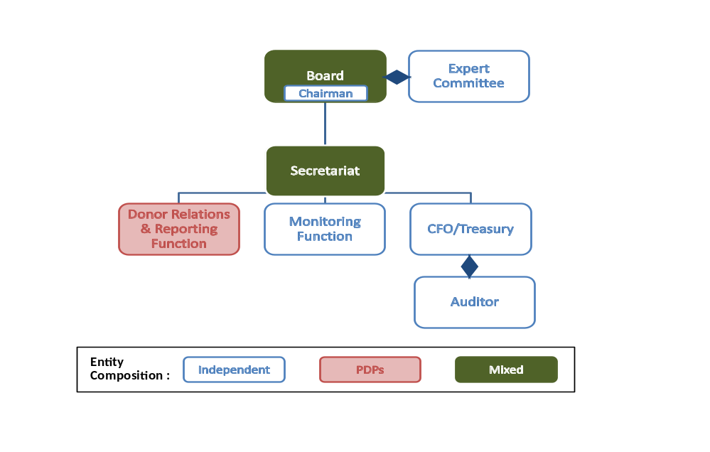
Figure 4: Structure of the PDPFF Board and Secretariat

Part III: Potential Benefits and Risks
- Potential Benefits of PDPFF
The proposal outlined above, if successfully implemented, could bring a number of important benefits.
Social and public health benefits. The AIDS, TB, and malaria vaccines that the three PDPs are working to develop would generate enormous public health, social, and economic benefits. Various studies have attempted to quantify the potential impact of these vaccines, and the PDPs and others continue to refine their estimates—a few figures are cited in Part I. The stable long-term financing provided by PDPFF could both increase the probability that these vaccines are developed and accelerate their development, licensure, and uptake.
Benefits to the PDPs. From the perspective of the PDPs, the bond funding would have important advantages of security, flexibility, and convenience, which would allow the PDPs to:
- Plan their R&D activities and investments with greater confidence that the necessary funding will be available
- Invest more quickly and nimbly in new projects as opportunities arise
- More easily attract and retain staff through greater job security and financial stability
Benefits to donors. From the point of view of the public sector and philanthropic organizations backing PDPFF, the proposed bond financing might be preferable to grants (or grants alone) in several ways:
- Payment for success – donors who agree to pay premiums on sales of new vaccines (“premium donors”) would subsidize the development of these products only if they come to market.
- Lower cost—to the extent PDPFF loans are repaid from royalties from middle- or high-income countries, the total burden falling on donors is reduced.
- Wider burden-sharing—by placing part of the burden of repayment on the shoulders of future donors to organizations such as GAVI and the Global Fund (via premiums), the PDPFF proposal would allow current donors to pass on or share some of the costs with others, including a number of the rapidly growing middle-income countries and others who may be major contributors to these health funds a decade or more from now. In a similar manner, if the vaccines generate substantial royalty payments from governments, health insurance organizations, and individuals in high and middle-income countries, these parties will in effect also help to share the financial burden of developing the new TB, AIDS, and malaria vaccines.
- Deferred payments—even in the worst case scenario, in which royalties contribute little to bond repayment and donors are obliged to make good on their guarantees, donors would in effect be deferring their payments for many years. This could be especially attractive in the current world financial crisis.
- Pooled support of PDPs—some donors who lack the expertise or appetite for managing the allocation of funding among different vaccine PDPs and programs may value the opportunity to support this joint mechanism. Donors who prefer to oversee allocation in detail would still be able to approve the initial expenditure plan and the reallocation rules, and could be represented on PDPFF’s governing body.

PDPFF also has some potential disadvantages to donors, including higher transaction costs, some loss of control over allocation and future funding decisions, and the difficulty of appropriately provisioning the loan guarantees to account for the possibility of revenues shortfall.

- Risks

- Insufficient revenues. The PDPFF proposal relies on revenues from royalties and premiums on vaccine sales to repay loans. Thus the possibility that the anticipated revenues will not materialize is a one of the most important risks, both to implementation of the scheme and to its operation. We have done our best, with the information in hand, to estimate likely revenues in a broad range of scenarios, and judge that revenues are likely to be sufficient to support borrowing with an NPV of $1-2 billion. However, these estimates are unavoidably uncertain. Vaccine development is inherently risky, and product development risks are compounded by uncertainties about demand and prices in both developing and developed country markets and about royalty and premium rates, and by institutional risks associated with donors, GAVI, PDPFF, and the PDPs themselves. These uncertainties, and possible ways to reduce them, are considered in more detail in Annex 1.

What are the implications for the PDPFF proposal? The most important risk is that donors will not believe revenues will suffice and will not be willing to guarantee PDP bonds. They may be reluctant to risk possibly substantial future payments to bondholders if PDPFF is unable to repay its loans. Moreover, the prospect of these future obligations may require them to “provision” the guarantees, that is, to place a substantial fraction of the guaranteed amounts in current budgets, which would make the proposal far less attractive.

The risk of revenue shortfall remains, of course, even if donors agree to guarantee the bonds and PDPFF is launched. Donors will therefore want to be assured that the PDPs will allocate the new capital most efficiently to maximize the chances of developing the target new product.

These concerns can be eased in several ways. First, the PDPs can try to increase confidence in their estimates of future revenues. There is some scope for this (see Annex), but substantial uncertainty will remain. Second, PDPs can reduce their projected borrowing, and thus the size of the guarantees they seek from donors, to a level that seems likely to be manageable even under pessimistic revenue scenarios. (There is probably a level below which the scheme no longer makes sense, however, as donors may not think it worth setting up an entirely new mechanism to handle only modest sums.) Finally, they can seek donors who are willing to accept that their guarantees may be called, and see PDP bonds nonetheless as an attractive way to support the PDPs.. Even with this acceptance, however, the problem of provisioning would remain, and few donors are likely to be eager to allocate substantial sums, especially in current economic circumstances, if the budgetary treatment of the guarantees is in the end nearly the same as providing grants upfront; this issue of budgetary treatment would need to be looked at closely if the PDPFF proposal is pursued.

From a donor perspective, another way of reducing their exposure if revenues are inadequate is to build into the guarantees agreements some claim on other PDP resources. Such a claim would not be attractive to the PDPs or to their grant donors.

In the next phase of developing this proposal, the PDPs will need to strengthen their analysis of future revenues, subject it to vetting by outside experts, and revise their proposed borrowing accordingly. They will also need to explore with potential donors the issue of budgetary treatment of guarantees, as it is not clear what degree of uncertainty about future repayment would trigger substantial provisioning for various donors..

- Risks associated with royalties and premiums. As discussed section IID, PDP bonds would in principle be repaid from royalties on vaccine sales in middle- and high-income countries and premiums on sales in low-income countries. In addition to the uncertainty about the amount of revenue that could be raised through these channels (see previous section), both mechanisms raise specific issues. We consider royalties first.

Although there are no theoretical or legal obstacles to the inclusion of royalties in agreements between PDPs and firms, there are at least three general circumstances in which this may be difficult or impossible. The most obvious case is that of existing, late-stage agreements, of which the agreement between MVI and GSK on RTS,S is an example. In this case, detailed terms covering access to and rights in various markets have already been agreed, and it would be difficult to go back and renegotiate royalty rights. One approach to existing agreements of this kind is to exempt them from the royalty obligation; another is to make PDPs responsible for making up from other sources the revenues that would have been gained from royalties on sales of these vaccines, in order to preserve the principle of fixed, universally applicable royalty rates. Finally, if the third of three royalty structures presented in Section IID were chosen, the problem would not arise, because no specific royalty rate is specified.

Another case is that of early-stage partnerships with biotech firms that are unlikely to bring a vaccine to market themselves. In these situations, when little is known about the characteristics of a product or its market prospects, it is difficult for either partner to negotiate specific terms related to markets and royalties, and it is easiest to defer these issues to a subsequent agreement. This should not be a problem, since both the current partner and any partner who may inherit the project will know that a modest royalty payment will be a standard feature of late-stage agreements with the PDPs.

Is there a danger that requiring royalties could cause some firms to shy away from collaborating with the PDPs? This is an important question that will require further examination and consultation, but the sense of our group is that in general it should be possible to incorporate some royalties into many agreements. The rate that could be negotiated, which we have set at 5% in most of our revenues analyses, will depend on the PDP’s relative contribution, in intellectual property, cash, and other forms, to the project and on the other options available to both partners. To allay the concern that high-priority projects could be blocked by the unwillingness of firms to agree to the specified royalty rate, we propose that PDPs be allowed to make up the difference from other sources (options 1 or 2), or that no specific target rate be set (option 3).

It’s worth remembering as well that the PDPs’ private sector partners as a group stand to benefit from the PDP bond scheme, since it would bring substantial new resources to PDP-industry collaborations.

Premiums on sales in poor countries raise another set of issues. First, it is very difficult to guess how much donors would be willing to pay through this mechanism. GAVI currently pays on the order $2-3 dollars per dose for Hib and pentavalent vaccines, but it has agreed to procure the new Pneumococcal vaccines through the AMC mechanism for $7/dose in the near term and about $3.50 thereafter. It is likely to pay as much or more for the new rotavirus and HPV vaccines and perhaps also for the existing 7-valent Pneumo vaccine. Any premium to PDPFF would be on top of the purchase price (or an additional component of this price if premiums were channeled through suppliers). Thus a $0.50 or $1 premium would constitute a substantial but not dominant share of the total cost of donors of procuring new PDP vaccines. In general, prices of vaccines can be expected to fall, as technologies become more widely available and new suppliers enter the market. For this and other reasons, we propose that premiums be paid only for the first 15-20 years of GAVI sales. The only way to determine a feasible premium rate is through discussions with potential donors.

Second, it is not clear how to give the premium mechanism a contractual basis. As discussed in Section II.D, writing this obligation into agreements with firms would solve this problem but might seriously inhibit these partnerships. The alternative of obtaining binding commitments from donors requires solving the issue of long-term contingent funding commitments. The role of GAVI is also unclear: it makes sense to tie the payments to sales funded by GAVI, but an agreement in principle from GAVI to pay the additional amounts does not help much unless it is accompanied by a commitment from GAVI’s donors. UNICEF, which actually procures the vaccines that GAVI pays for, is implicated only if the premium is included in the purchase price of the vaccine. These issues require further work.

- Loan guarantees and loss provisioning by guarantors. Loan guarantees are a standard tool used by all governments and appropriate accounting mechanisms are well established. In that sense, there is no a priori reason why most or all of the OECD governments should not be able to provide guarantees to PDPFF.

There are, however, differences in how the various governments account for such guarantees. In general, under "classic style" government accounting (used in countries like Australia, Canada and Japan), a guarantee would be provisioned up-front for its expected loss. In the European Union, while individual countries may provision for their own purposes, in the budget recorded by Eurostat a guarantee only appears in the budget when it is called, i.e. when a loss actually occurs. The US has a blend of these two models in which the theoretical loss is provisioned under the appropriations process, but the budget operates on a cash basis, recording actual losses.

The way that expected losses are calculated also varies from country to country. Some have clear rules prescribed and scrutinized by separate agencies, while others leave this to the discretion of the government department responsible for the guarantee program.

Finally many countries have development banks that are themselves guaranteed by their respective governments. These may prove to be a convenient tool for governments to participate in the PDPFF structure without providing direct guarantees themselves.

Despite this variation in practice on budgeting and loss provisioning, the appeal of PDPFF to the broadest range of government donors will depend on the ability of the government to evaluate the risk of insufficient revenues to repay the loans (and hence the need to call down the guarantees). Given that the PDPs work in areas that are hard to fully evaluate from a risk perspective, we will need to explore how individual donors would approach the provisioning of their exposures to PDPFF. Ultimately this will only be known by opening a dialogue with one or more of the most relevant donors.

- Unwillingness or inability of an MDB to serve as an intermediary. As discussed in Chapter II, PDPFF could theoretically borrow in capital markets as a stand-alone entity, but it would be far more efficient for the Facility to operate as a captive of an MDB such as the World Bank or European Investment Bank. But no MDB may be able (or may be unwilling) to play this role, which would represent a departure from its established functions.
We have had some promising informal conversations on this issue with senior financial and legal staff at the World Bank. These discussions suggest that the Advance Market Commitment, which is close to implementation, might provide the right kind of precedent for the PDPFF, since the World Bank will be using its balance sheet to make the price support payments to vaccine suppliers, drawing on payment commitments from a number of donors. But much more needs to be learned from discussions with World Bank staff and board members. We need to explore, for example, other precedents that might make it easier for the World Bank to take on PDPFF. If it turns out that we are breaking entirely new ground, the political and technical challenges within the World Bank could be significantly greater. We should learn whether there are other significant legal, financial, or other obstacles that would have to be overcome. And we also need to get a better sense of what the World Bank would be likely to charge PDPFF in the form of fees and interest rate spreads (if any) on the funds it re-lends to the Facility. The backing of important shareholders in the World Bank will be an important additional factor about which we need to gather more information.

- Governance and operation. PDPFF will be less attractive to donors, PDPs, and others if its governance and operations become too complex, entailing heavy administrative costs to the PDPs or to their donors.. The up-front costs to the PDPs, donors, and an MDB to establish and launch PDPFF could also become large. In addition, PDPFF Board could be slow to take decisions and add another burdensome layer of decision-making and reporting to donors on top of what the PDPs already do. Some recent development financing mechanisms in health such as IFFIm and UNITAID have been criticized for large and possibly unnecessary establishment and operating costs.
We have tried to avoid, or minimize such costs with PDPFF in a number of ways, including:
- Keeping its Board small
- Using PDP staff to perform some secretariat tasks
- Limiting the number of resource allocation decisions the Board has to take

More could be learned from recent experience with other innovative financing programs to keep the PDPFF arrangements as simple and inexpensive as possible.
There is also the unresolved issue of representation on the PDPFF Board: will the majority of the members come from the sponsoring donor governments or from the PDPs themselves? And what proportion of Board seats should be filled by independent persons? This will be an important issue to discuss with potential sponsoring donors.
- Cooperation among the PDPs. For PDPFF to succeed, the three vaccine PDPs (and perhaps others) would have to agree to an unprecedented degree of coordination in their financial planning, fund-raising processes, and negotiations with industrial partners. Under PDPFF the PDPs would adopt common approaches to estimating financial needs, jointly request bond guarantees from donors, agree to a system for allocating bond funds, adopt a common policy on incorporating royalties and premiums into agreements with firms, and follow a common system for reporting to the donors.
Are there significant legal, “cultural”, or other factors that might prevent the three PDPs from achieving this degree of cooperation? This is another issue that needs to be probed in the next stage of this project.
- Risks to grant funding. In preliminary conversations with the three PDP CEOs and members of our technical group, concerns were raised about whether a successful PDPFF would end up reducing the amount of funding coming to the PDPs from donors in the form of “push” grants. Wouldn’t donors who put up bond guarantees cut back on, or eliminate, their grants to the PDPs?
This is a legitimate concern. We have not yet attempted to get an idea of how the existing PDP donors would react if the PDPFF were established. It is conceivable that the volume of grants would fall off, or would (almost certainly) be smaller than in the absence of PDPFF. However, the three PDPs could still be considerably better off overall with PDPFF up and running, even if some grant funding is lost:
- Some donors would almost certainly decide not to provide guarantees and would continue to make grants.
- Some donors might decide to provide a mix of guarantees and traditional grants, as they have done with IFFIm (contributing to GAVI both through this new mechanism and through traditional grants). If, in the end, funds from guaranteed bonds are used only or primarily for a subset of PDP expenditures (for example efficacy trials), then donors would have a clear rationale for extending grants for other R&D activities (in this example, for vaccine design and other pre-clinical activities).
- Even if there is some substitution of guarantees for grants, the former should be seen as more valuable (dollar for dollar) than grants, since resources flowing from the guarantees would be more long-term, predictable, and perhaps flexible than the resources from traditional grants.
If the PDPs decide to pursue further the PDPFF idea, this issue of substitution of bond guarantees for grants would have to be explored with current and potential future donors.

- Conclusions and Next Steps
Our technical group has invested substantial time and effort in designing and assesing the feasibility of the PDP Financing Facility as an innovative mechanism for mobilizing stable and flexible financing for the three leading vaccine PDPs, and potentially, for other Product Development Partnerships. The group considers the PDPFF to have considerable promise, but it recognizes the complexities and risks involved in designing and launching such a new funding facility.
If the three PDPs decide to move to the next step, our group suggests that a number of presentations and discussions with other stakeholders should take place in the coming months, especially with prospective donor champions and the MDBs.
Annex: Modeling PDP Financing Facility revenues and expenditures

I. Revenues
This annex analyzes potential revenues to the PDP Financing Facility from the two sources described in Section IID, royalties and premiums on vaccine sales. We consider a number of scenarios regarding the success or failure of individual products and the impact of different assumptions about royalty and premium rates and prices. We discuss the most important sources of uncertainty at the end of the section.
A. Approach and model
We have estimated revenues using a simple spreadsheet model that calculates royalties and premiums flowing from each of a small number of potential products by applying a percentage royalty (fixed for each scenario) to sales in middle- and high-income countries and a per-unit premium on GAVI sales.
The products (two for IAVI, three for Aeras, and three for MVI) were chosen to represent the major classes of potential products (for example, “infant boost TB vaccine” or “second-generation HIV vaccine”) rather than specific candidates (See Table 1). Demand projections for each product and likely prices in each market were obtained from the three PDPs and adapted to the model. Demand for each year from launch to 2040 was broken down by country and, in some cases, by public or private market.

Table 1: Vaccines considered in the analysis
Vaccine | Description | Launch
Aeras 1 | “Recombinant BCG”: Genetically engineered improved BCG. | 2017
Aeras 2 | “Infant boost”: Boost vaccine given after BCG or new BCG. Could be any of several boost candidates. | 2016
Aeras 3 | “Adolescent boost”: Could be any of several boost candidates. | 2016
MVI 1 | “RTS,S”: GSK vaccine going into Phase 3 in 2009. Low to moderate efficacy, P. falciparum only, no sales outside Africa, no travelers or military market in high-income countries. | 2013
MVI 2 | Moderately effective vaccine (80%) against P. falciparum. No demand projection estimates available. | 2020
MVI 3 | Highly effective combination (P. vivax and P. falciparum) vaccine (90%), substantial sales to travelers and military. | 2025
IAVI 1 | Modestly effective vaccine (50% efficacy, 3-year duration); base scenario in IAVI demand paper. Could interpret as optimistic scenario for current generation of T-Cell candidates. | 2023
IAVI 2 | Second-generation vaccine (90% efficacy, 5 -year duration); optimistic scenario in demand paper. Could interpret as optimistic outcome of Neutralizing Antibody work. | 2028

In most of our analyses, we assumed royalties of 5% in both middle- and high-income countries and a $1 premium on GAVI sales, but we consider a scenario with lower royalty and premium rates, and analyze the sensitivity of our estimates to these rates. Both royalties and premiums were assumed to flow for twenty years after launch. Total revenues were discounted to 2010 at 5%.
The model allows royalty and premium rates and terms, product prices, and the discount rate to be varied easily. Different scenarios of product success and failure are also easily modeled. It is somewhat more difficult to change launch years, demand projections, and country assignments, or to model royalty rates that vary across the products of a particular PDP and prices that change with time.
The model also allows a probability of success to be assigned to each vaccine. In this way a “probability-weighted” estimate of total revenues can be calculated. However, these probabilities are very difficult to assign, and we believe it is more informative to consider a range of scenarios defined explicitly by the success or failure of individual products.
B. Scenarios
We consider five scenarios.
1. All vaccines
This is not a plausible scenario, but gives a sense of maximum possible revenues.
2. Optimistic
RTS,S (MVI1), the highly effective malaria vaccine (MVI 3), Recombinant BCG (Aeras 1), TB adolescent boost (Aeras 3) and the second-generation AIDS vaccine (IAVI 2) all come to market.
3. Intermediate
RTS,S, Recombinant BCG, and TB infant boost (Aeras 2) reach the market.
4. Pessimistic
Only RTS,S and Recombinant BCG make it to market.
5. Low royalty
The same vaccines come to market as in the optimistic scenario, but the royalty rate is 2% instead of 5% and premiums are $0.50 instead of $1.00.

Table 2: Vaccines success scenarios
 | Aeras 1 | Aeras 2 | Aeras 3 | MVI 1 | MVI 2 | MVI 3 | IAVI 1 | IAVI 2
1. All Vaccines | + | + | + | + | + | + | + | +
2. Optimistic | + |  | + | + |  | + |  | +
3. Intermediate | + | + |  | +
4. Pessimistic |  | + |  |  | + |  |  | +
5. Low Royalty | + |  | + | + |  | + |  | +

C. Results
Total revenues to PDP Financing Facility in our scenarios (excluding the unrealistic Scenario 1) range from $2.2 to $6.9 billion. If these revenues are discounted to 2010 at rate of 5%, they yield a net present value of $0.9 to $2.3 billion.
Both royalties and premiums contribute substantially, but the contribution of premiums is greater, ranging from 66% in scenario 2, in which an AIDS vaccine brings in significant revenues in industrialized countries, to 89% in scenario 5, which is dominated by RTS,S, a vaccine with little prospect for sales outside GAVI countries. All three PDPs make a meaningful contribution, although MVI is the largest contributor. However, these findings depend strongly on assumptions about royalty and premium rates (see Section D). A different balance of royalty and premium rates could substantially alter the relative contributions of the two revenue streams and of the PDPs.
Table 3: Model outputs
 | All | Optimistic | Intermediate | Pessimistic | Low Royalty
Outputs | Scenario 1 | Scenario 2 | Scenario 3 | Scenario 4 | Scenario 5
Royalty rate | 5% | 5% | 5% | 5% | 2%
Premium | $1.00 | $1.00 | $1.00 | $1.00 | $0.50
Total revenues (2010 NPV), $bill. | 3.3 | 2.3 | 1.2 | 0.9 | 1.1
Total revenues, undiscounted, $bill. | 10.2 | 6.9 | 2.9 | 2.2 | 3.2
Royalty percentage | 45% | 34% | 12.7% | 10.8% | 29%
Middle-income countries | 11% | 11% | 8% | 6% | 9%
High-income countries | 34% | 23% | 5% | 5% | 20%
Premium percentage | 55% | 66% | 87% | 89% | 71%
Aeras percentage | 23% | 24% | 51% | 38% | 24%
MVI percentage | 32% | 47% | 49% | 62% | 50%
IAVI percentage | 44% | 29% | 0.0% | 0.0% | 26%

The following graphs show the time profile of revenues in two of the scenarios. Revenues cut off suddenly in scenario 3 because the assumed 20-year term for royalties and premiums expires.
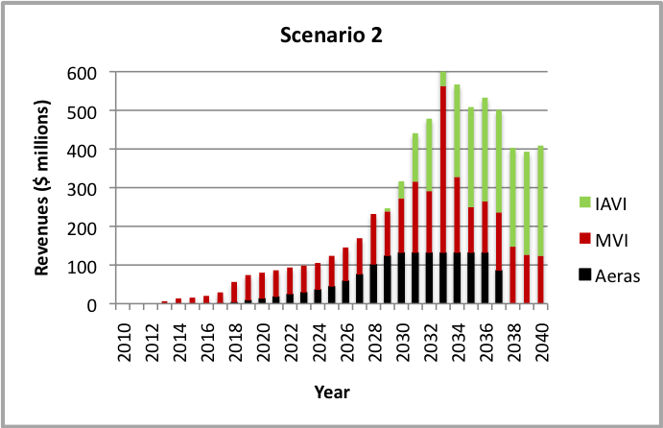
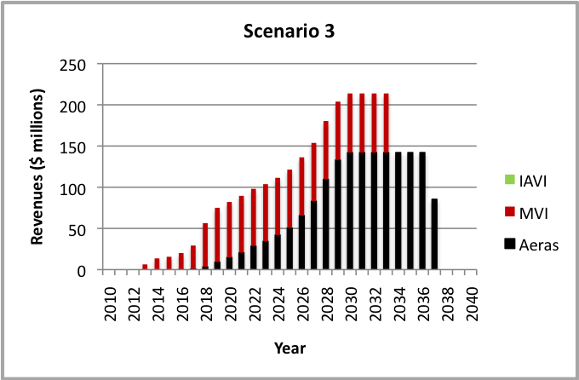

D. Sensitivity analyses and sources of uncertainty
These estimates are sensitive to parameter values (royalties, premiums, prices, etc.) and demand data, as well as to structural assumptions of our model. The following graphs show the impact of changes in various parameters on net present value of revenues in Scenario 2.
1. Discount rate: Our estimates of NPV are highly sensitive to the discount rate, as the next figure illustrates. The appropriate rate to use depends on the purpose of the analysis. In our case, it seems appropriate to use the inflation-adjusted rate of interest that PDPFF can expect to pay bondholders, which is likely to be much lower than the rates that industry uses in rate-of-return calculations. In general, we have assumed a 5% discount rate in the model.
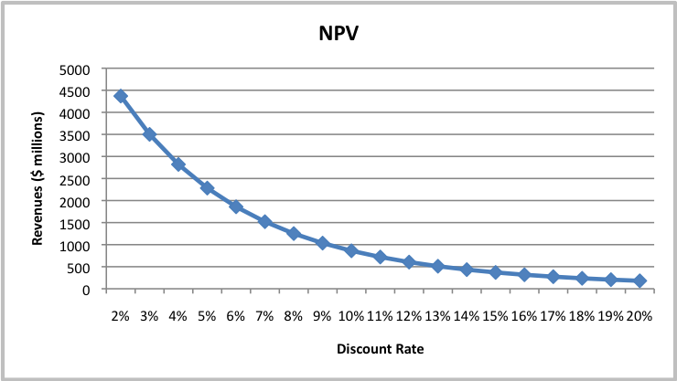

2. Royalties and premiums rates. Our revenues estimates also depend directly on our assumptions about royalty and premium rates.
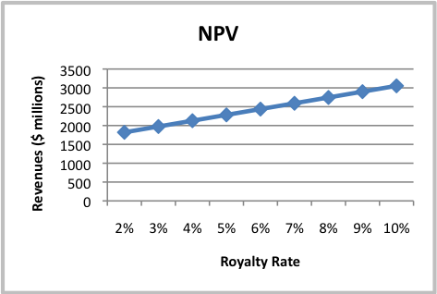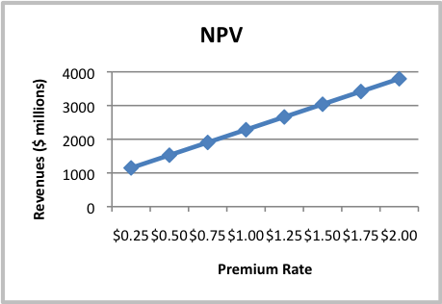

The royalty and premium terms matter too, especially in the scenarios that rely heavily on vaccines that come to market relatively early (RTS,S and the Aeras vaccines). We have generally assumed a royalty and premium term of 20 years.

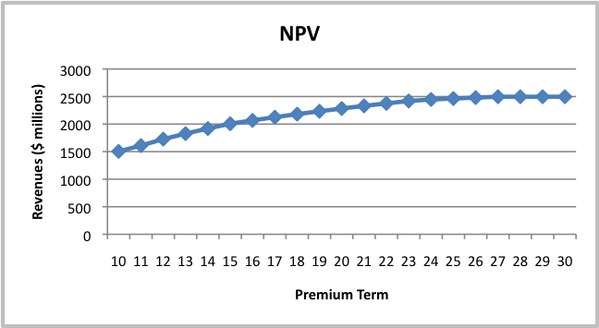

It should be possible to put our assumptions about both royalty and premium rates on a more solid footing through further work with the general counsels and business development staff at the three PDPs, consultations with potential premium donors, and perhaps informal discussions with industrial partners.
3. Prices. Income from royalties is determined by prices as well as sales volumes and royalty rates (premiums do not depend on price in our model). Vaccine prices have changed a great deal in recent years and continue to evolve. In high-income countries, new vaccines now command prices above $100/dose; this trend is likely to continue. In middle-income countries, the price of new vaccines is greatly contested, but at least some governments have agreed to purchase new vaccines for more than $20/dose, substantially more than they have paid for traditional childhood vaccines. It seems likely that countries with a significant HIV burden would be willing to pay this much for a reasonably effective AIDS vaccine. These countries are used to paying pennies for BCG vaccine against TB, however, and may resist paying much more for a new one. Moreover, the sustainability of these higher prices for middle-income countries may depend on the emergence of donor subsidies for lower middle-income countries that are not currently eligible for GAVI. As a result, it is possible that the prices used in our projections, which were provided by the three PDPs, are off by as much as a factor of ten, especially for middle-income countries. But with a number of new vaccines being introduced over the next few years, it is likely that we will have a much better sense of price trends soon.
Our model currently assumes that the price of each vaccine in each class of countries is fixed throughout the period of the analysis, which ranges from 12 years for a second-generation AIDS vaccine to 27 years for RTS,S. In reality, vaccine prices tend to fall as technology spreads and new suppliers enter the market. This will reduce revenues to PDPFF, although how much will depend on the royalty term.
4. Product development. Vaccine development is a highly uncertain business, and the chance of any one candidate coming to market is small, very small indeed at early stages. Even though most of the products that we’ve included in our revenues model are in reality more or less narrowly defined classes of products for which several candidates are or will be in development (giving the PDP several “shots on goal”), it is probably safe to say that the aggregate chance of any one of these products reaching market is in many cases less than 50/50. This is the largest source of uncertainty in the revenues calculations and one of the most difficult to estimate, since probabilities of success from industry experience in general apply poorly to the vaccines of the three PDPs, and almost entirely irrelevant in cases where fundamental scientific breakthroughs will be required to generate viable candidates. There may be some value in estimating the likely number of independent candidates in each of the PDP’s current and future portfolios and in assigning probabilities of success to each to arrive at a probability-weighted estimate of revenues, or even in carrying out a Monte Carlo simulation. But, since in most cases these probabilities would have to be assigned without much basis, such an exercise would risk lending a false air of precision to the estimates.
5. Demand. Revenues from premiums depend on demand in low-income countries, while income from royalties depends on sales in high-income and perhaps middle-income countries. Estimating adoption and uptake of new vaccines in developing countries is difficult, although these projections are becoming more sophisticated. In principle, demand in high-income countries should be easier to project, but prospects for AIDS vaccines in particular (which have the greatest potential for rich-country revenues) are unclear.
The demand projections used in our analysis could be improved in several ways. We could make better use of the models that the three PDPs already have and address gaps in these models in a more sophisticated way. Both Aeras and MVI are in the process of updating and improving their demand projections – our revenues analysis could be revised when the new results are available. Demand for AIDS vaccines will remain very difficult to project, as little is known about the characteristics of future vaccines and epidemiological conditions may change greatly before a vaccine comes to market.
It would be worth revisiting one component of AIDS vaccine demand, however: sales in high-income countries. Royalties on these sales are the single greatest potential source of revenue for PDPFF, yet projections of demand in these countries are the weakest element of IAVI’s global demand study.
6. Institutional risks. The final source of uncertainty in our revenue estimates derives from the risk that the institutions on which these payments depends, fail to meet their commitments or do not survive in their present form. We have tried to project revenues over thirty years – over such a long time, firms could go out of business, GAVI could cease to exist, and the PDPs themselves could disappear. Even if these organizations survive, the arrangements that we have outlined could fail. There is no easy way to estimate the magnitude of these risks, but anticipating them and developing ways to forestall them must be a high priority in refining our proposal.

E. Conclusions
Our analysis suggests that PDPFF could have substantial revenues, if both royalties and premiums can be successfully attached to PDP vaccines. These revenues would be sufficient to allow PDPFF to pay for a meaningful share of the cost of developing these vaccines (see below). Moreover, each of the three PDPs has a good chance of contributing significantly to the total, although the actual share depends on which vaccines come to market.
These estimates are unavoidably uncertain. Further analysis could reduce this uncertainty to some degree, but the most important sources of uncertainty will remain intractable.

II. Potential expenditures
Are the revenues estimated in above sufficient? One way to answer this question would be to try to project how much money the three PDPs will need over the next 15 years or so and how much they are likely to receive from existing sources (grants from foundations and governments), and to derive in this way a “gap” to be filled by PDPFF. But this would be very difficult to do and any guess as to what donors will provide 10 years from now seems almost meaningless. Another way to look at the relationship between revenues and needs is to ask how much R&D the estimated revenues would support.
As a first simple exercise, we asked how much each PDP borrow could from PDPFF every year for a fixed period beginning in 2010, on the assumption that projected revenues were just sufficient to repay the loans, in two scenarios. As the table shows, these revenues could in theory support annual expenditures on the same order of what the PDPs spend today, sustained for 10 years or more.
Table 4: Expenditures per PDP, under Scenario 2
 | Annual borrowing per PDP ($millions)
 | Scenario 2 (optimistic) |  | Scenario 4 (pessimistic)
Interest rate | 10 years | 15 years | 10 years | 15 years
3% | 137 | 98 | 50 | 36
5% | 99 | 73 | 39 | 29
7% | 72 | 56 | 31 | 24

Would the resources of PDPFF be sufficient to fund late-stage efficacy trials? It is difficult to predict how many of these trials each of the PDPs will undertake; we assumed that an average of two Phase 2B (or “STOC”) trials and 1.5 Phase 3 trials would be carried out for each of the 8 products included in our analysis. Using estimates of trial costs and duration from the three PDPs, we estimate total Phase 3 costs at $2.3 billion; including Phase 2B costs adds another $440 million. Discounted to 2010 at 5%, these costs come to $1.7 and $2.0 billion. If money could be borrowed at this rate, the revenues projected in the three more pessimistic scenarios would be insufficient to pay for all Phase 3 costs, while revenues from the more optimistic scenario 2 would enough to cover both Phase 3 and Phase 2. The next graph shows the pattern of expenditures and revenues over the 30-year life of PDPFF in the second scenario (revenues as in Scenario 2, both Phase IIB and Phase III).

Although efficacy trials might be the most important use of PDPFF funds, they would probably not be the sole use. It would be useful to look at other scenarios including other kinds of expenditures, especially for IAVI.

This idea was first proposed by Christopher Egerton Warburton, a capital markets specialist who played a central role in the design and launch of the International Finance Facility for Immunization. Warburton joined the technical group and is one of the authors of this report.
The range of estimates reflects different scenarios of vaccine success and failure. 3 of 4 scenarios assumed a 5% royalty and a $1/dose premium; in the 4th, the royalty was 2% and the premium $0.50/dose.
J. Stover et al., “The Impact of Aids Vaccine in developing countries: a new model and initial results,” Health Affairs 26, no. 4 (2007).
Maire N., et al., “Predictions of the Epidemiologic Impact of Introducing a Pre-Erythrocytic Vaccine into the Expanded Program on Immunization in Sub-Saharan Africa”. American Journal of Tropical Medicine and Hygiene 75, Suppl. 2 (2006): 111-118.
The rich-world market for AIDS vaccines might be quite substantial—in this case scientific challenges may be at present the single greatest deterrent to private sector investment. Expenditures by industry currently account for less than 10% of annual expenditure on AIDS vaccine R&D.
According to the recent report from the George Institute, the eight largest PDPs spent about $380 million in 2007. George Institute (2008): “Neglected disease research & development: How much are we really spending?”.
Vaccine development in general takes longer than drug development, in part because of the very large trials required to show that a new vaccine reduces disease incidence. The greater stringency of regulatory requirements for a product that will be given to healthy people contributes as well.
Multilateral Development Banks (MDBs) include the World Bank, the European Investment Bank, the Inter-American Development Bank, the Asian Development Bank, the African Development Bank, and others. This is discussed further below.
Although some members of the group felt that donors, especially European governments, would not want to be formally represented on the Board, the majority view was that donors would want substantial influence, if not direct control.
The Bank for International Settlements (BIS) has developed a set of criteria by which it assesses whether an institution qualifies as an MDB. This same framework is used by the European Commission.
The PDP’s budget may also include funds due to be disbursed according to previous agreements with PDPFF.
Many of the issues raised in this section would disappear if each PDP could draw on a dedicated source of loans, backed by dedicated guarantees, which it would be responsible for repaying from its own revenues. In this case, each PDP would be free to negotiate separately with its guarantors and no PDP would have an interest in how the others used their funds. But the proposal we are considering here depends on pooling of guarantees and revenues, since this pooling substantially reduces risk to donors providing guarantees.
If donors provided guarantees only to individual PDPs, which then transferred them to PDPFF, the PDP share could be equal to the its share of guarantees. But it may be necessary to set additional limits on shares, since each PDP would be borrowing against a common pool of anticipated revenues.
Projected revenues should not, in our view, be a dominant consideration in setting the shares of the PDPs, since these revenues are highly uncertain and since those that come from GAVI premiums (see next Section) would not be available to individual PDPs outside of the PDPFF.
Actual shares cannot add up to more than 100%, but ceilings must if there’s to be any flexibility in allocation.
In this plot we have excluded Phase 3 trial expenditures for MVI’s candidate RTS,S, but these costs are included in the analysis presented in Annex 2.
Proceeds from the licensing or sale of “incidental IP”, technologies developed in the course of PDP-sponsored research that might have value in applications other than the vaccines on which the PDP works are another possible source of revenue to PDPs that could be used to support PDPFF. Another source could be revenue from services provided by a PDP on a contractual basis. We have assumed that this kind of income would be small compared to royalties and premiums on vaccine sales and not attempted to estimate its potential contribution. But these revenues would be captured for PDPFF in option C below.
Determining which vaccines to include may not be trivial, since the contribution of PDPs to the development of products can be quite modest in some cases.
As mentioned above, certain vaccines already in late-stage development could be exempted.
This percentage would presumably have to be high to generate sufficient revenue for PDPFF.
Allowing PDPs to retain some fraction of these revenues would provide some incentive, but these revenues would only become available many years after the time agreements are negotiated. In any case, PDPs are currently able to retain 100% of any royalties they negotiate with firms.
If options B or C were chosen, the projections would have to be redone with royalty rates that vary among vaccines, although a uniform rate could be taken to represent a sales-weighted average rate.
Countries with a gross national income of less than $1000 per capita in 2003 are currently eligible for GAVI support. The 72 qualifying countries include all those classified as low-income and 23 currently considered “lower middle-income”. GAVI may revise its eligibility criteria in 2010.
In other words, some of the donors who provided guarantees would make grants to PDPFF at this time. In some circumstances this may be preferable to some donors, for accounting and other reasons, to being forced to make good on the guarantees at the time the debt matures.
Some donors may want to build into the guarantee agreements some resource to other resources of the PDPs in the case of revenue shortfall. See Section IIIB.
The extent to which this benefit is realized depends on the flexibility of PDPFF allocation rules, in particular the ease of reallocating planned expenditures.
A major challenge to realizing this potentially quite important benefit (from the perspective of current donors) is the need to put in place now commitments to pay premiums in the future.
This argument has also been made for the “Neglected Disease R&D Fund” proposed by the International Federation of Pharmaceutical Manufacturers and Associations.
Nonetheless, there is a risk that future partners may find terms agreed with a biotech partner unacceptable.
We also consider a scenario in which the average royalty rate is only 2% (scenario 5 in Table 2).
Since we’re concerned here with revenues, these “classes” of products are not defined in general by scientific hypotheses or technologies, but by the characteristics that would determine their uptake in the various markets. The hope is that together they represent most of the potential PDP products that could bring in substantial revenue. The definition of vaccines for this analysis was also influenced by the kinds of products for which demand projections were available.
The analysis was run to 2040 to allow the AIDS vaccines to enter the market and accumulate significant sales. If the first bonds were sold in 2010, the longest term available would be 30 years.
In general, the demand projections for individual vaccines in our model are invariant—that is, they do not take into account the effect of other vaccines on demand. In some cases, where vaccines would compete with or replace each other, this is obviously unrealistic. Since demand projections for different competitive scenarios are not available, we account for these effects in two ways. First, in defining the scenarios that we consider in detail, we avoid combinations of vaccines that would compete for very similar markets. None of or scenarios includes both IAVI vaccines or both the infant-boost and adolescent-both TB vaccines. The replacement BCG and one of the boost vaccines both come to market in several scenarios, as these vaccines are assumed to complement each other rather than compete. Second, in cases when both RTS,S and one of the improved malaria vaccines come to market, African sales equivalent to those of RTS,S are subtracted from sales of the later vaccine. Although in reality the new vaccine might replace RTS,S, for the purposes of all model it doesn’t matter very much which vaccine is awarded those sales, since most are in GAVI country where a uniform premium rate would apply.
A royalty rate of 5% was chosen on the basis of conversations with Labeeb Abboud of IAVI and Donald Keleman of MVI, who suggested that “mid-single-digit rates” seemed feasible, at least for new deals. A fixed, across-the-board royalty rate is only one of three possible royalty structures that we propose—other options are a set of target rates for different circumstances and a fixed percentage of PDP income from this and other sources, without a target royalty rate. For the two latter options, the royalty rate in our model can be interpreted as a weighted average of the potentially quite different rates for different vaccines. The choice of $1 for the premium rate was quite arbitrary. This amount is less than the approximately $4 limited-time price mark-up that GAVI will pay for Pneumococcal vaccine under the AMC framework and a modest fraction of the likely GAVI price of other new vaccines, but it is large compared to the prices of many vaccines that have long been on the market in developing countries.
The jump in demand for malaria vaccines in 2033 scenario 4 apparently results from large catch-up campaigns in the first year of adoption, probably in India.
Since relatively few vaccines have been licensed, industry averages such as those published by Struck (1996) are not statistically robust; in addition, the vaccines that the three PDPs are trying to develop are almost certainly more difficult to develop than most. Finally, while industry experience may give some hint of the chances of progressing from one stage of clinical development to another, it provides little guide to the odds of overcoming the major scientific obstacles that impede development of vaccines at earlier stages.
This analysis thus does not include much allowance for trials of candidates that fail. In theory, these trials could be added, but in practice it’s very difficult to estimate the ratio of failed to successful trials, especially for AIDS, TB, and malaria, which have almost no track record.

